Identifier:  AP Mini V8.3-3 | Revision:  09 | Effective Date:  11/24/26
Document Catalog Number: 0001
Author: William E Rison
AP GTO Mini Control

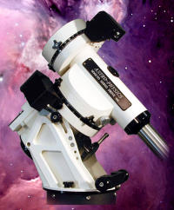
User Guide

Copyright © 2026 [William E Rison]. All rights reserved.
No part of this publication may be reproduced, transmitted, transcribed, stored in a retrieval system, or translated into any language, in any form or by any means, electronic, mechanical, photocopying, recording, or otherwise, without prior written permission from [William E Rison].
All copyright, confidential information, patents, design rights and all other intellectual property rights of whatsoever nature contained herein are and shall remain the sole and exclusive property of [William E Rison] Ltd. The information furnished herein is believed to be accurate and reliable.
However, no responsibility is assumed by [William E Rison] for its use, or for any infringements of patents or other rights of third parties resulting from its use.
The [Company] name and [William E Rison] logo are trademarks or registered trademarks of [William E Rison] Limited.
All other trademarks are the property of their respective owners.

Document History
Revision History
Revision Number | Revision Date | Summary of Changes | Author
8.2-3 | 02/09/2015 | Fixed network mask on Use remote network for dome controller emulator.  Added better log file entries for error messages.  Added a splash screen. | William Rison
8.2-4 | 02/19/2015 | Older version is uninstalled automatically before installing the new version. No longer need to do program remove before updating with new version. | William Rison
8.2-6 | 02/26/2015 | Fixed not knowing RA/DEC and sidereal time when connecting to NCO dome controller.  Will send INIT to NCO dome controller if dome position is not known during connect to NCO dome controller.  Spelling fix for controller version. | William Rison
8.2-7 | 03/01/2015 | Calc dome position is now done if dome position is unknown when enabling tracking. | William Rison
8.3-0 | 03/02/2015 | Upgraded to .net framework 4.0 client to fix splash screen issue. Changing framework version looses previous settings. | William Rison
8.3-1 | 03/03/2015 | Message box for COM port not found during startup was hidden behind splash screen. | William Rison
8.3-2 | 03/04/2015 | Removed splash screen being shown during startup.  Added context menu to show serial ports window. | William Rison
8.3-3 | 03/06/2015 | Search now issues a mount stop when closed if search is active | William Rison
Distribution
This document has been distributed to:
Name | Title
Table of Contents
1. System Description & Function 8
1.1. Files and Folders 8
1.2. Environment 8
2. Program Functions and Windows 10
2.1. Splash screen 10
2.2. Main Window 11
2.3. COM Serial Port 12
2.4. Connect / Disconnect 12
2.5. Keys 13
2.6. Status Bar 13
2.7. Centering/Guide/Slew 14
2.8. Focus 16
2.9. Stop Mount Tracking Options 17
2.10. Tracking Rate 18
3. Menu > Main Menu 19
3.1. Settings - Sub Menu 23
3.2. Settings > Colors - Sub Menu 25
3.3. Settings > COM settings – Sub menu 25
3.4. Settings > Speak rate – Sub menu 27
4. Command Log – Window 28
4.1. File – Menu bar 29
5. Save & Restore RA/DEC - Window 30
5.1. File – Menu 31
5.2. Control – Menu 32
5.3. Menu Bar – Buttons 33
5.4. Context Menu – Popup 33
6. GTOCP3 Tracking - Window 35
6.1. File – Menu 36
7. Scope & Dome Position – Window 38
8. Dome Control Window 39
8.1. NCO Controller – Tab 40
8.2. AGF Controller – Tab 41
8.3. Dome Azimuth – Controls 42
8.4. Mount Azimuth – Controls 43
8.5. Tracking – Controls 43
8.6. Dome Position Calculation 44
8.7. Status Line – Text 45
8.8. Show/Clear – Menu 46
8.9. Domes File – Menu 47
8.10. NCO Control - Menu 48
8.11. AGF Control – Menu 49
9. Dome Command log – Window 51
9.1. File – Menu bar 52
10. RA/DEC Window 53
10.1. Functions – Buttons 53
10.2. RA – Number boxes 54
10.3. DEC – Number boxes 54
10.4. Mount Position – Text 55
10.5. Status Line – Text 55
11. Altitude/Azimuth Window 56
11.1. Functions – Buttons 56
11.2. Altitude – Number boxes 56
11.3. Azimuth – Number boxes 57
11.4. Mount Alt. Az. Position – Text 57
11.5. Status Line – Text 57
12. Time and Date – Window 58
13. Diagnostics Adjustments – Window 60
14. Re-calibrate – Window 61
15. About and Help – Window 62
16. Installing, Starting and Stopping the System 63
16.1. Installing the system 63
16.2. Upgrading from previous version 63
16.3. Starting the system 63
16.4. Stopping the system 63
16.5. Uninstalling the system 63
17. Step by Step Instructions for using the system 64
17.1. Serial COM Port Connections to Mount 64
17.2. NCO Dome Controller Connection 64
17.3. AGF Dome Controller Connection 64
17.4. Starting the Program 64
17.5. Errors, Malfunctions, and Emergencies 64
18. Quick-Reference for NCO Observatory 66
19. Appendix A – Reference Documents 68
20. Appendix B – Glossary of Terms 69

System Description & Function
Control of Astro-Physics telescope mounts that have a GTO Servo Controller GTOCP1, GTOCP2 or GTOCP3. These controllers are found on the following mounts.
- Mach1
- 400GTO
- 600GTO
- 900GTO
- 1100GTO
- 1200GTO
- 1600GTO
- 3600GTO
Two different custom observatory dome rotation controllers are supported.
- NCO dome controller (located on the 16’ Ash dome at NCO)
- AGF dome controller (located on the 2 meter Sirius dome at MHO)
Observatory dome controllers are not required to control an AP telescope mount.
The program can be set to automatically have a dome controller track the telescope mount.

Files and Folders
Program can be downloaded from a zip file located at AP GTO Mini Control download

Software will install to the following locations on the system disk drive:
- Program Files > Telescope Control > AP GTO Mini Control (32bit Windows OS)
- Program Files (x86) > Telescope Control > AP GTO Mini Control (64bit Windows OS)

A desktop shortcut is created with the icon:

Environment
Program will run under Microsoft Windows 32bit or 64bit operating systems that support .NET Framework version 2.
Has been successfully run on Windows Xp, 7, 8, 8.1.

Serial COM devices are required to communicate with the Astro-Physics GTO Servo Controller on the telescope mount. The Top RS-232 connector should be used to prevent timeouts but the Bottom RS-232 connector will also work. A few timeouts can be handled by the program.
The following type of Serial Devices have been tested and used:
- Standard built-in serial ports.
- USB to serial adapters.
- Bluetooth serial adapters.

A network connections is required to communicate with the NCO Dome Controller. Wired and wireless networks are supported.

Program Functions and Windows
Describes all program functions showing each control grouped by what window is being used.
When the program is started the following splash screen.

Splash screen
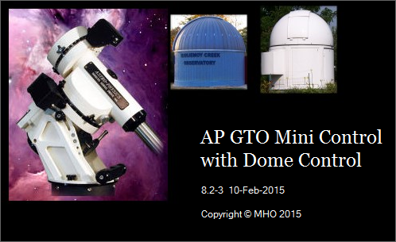

Displayed from the settings sub menu of the main window Menu. Has been disabled during startup.

Main Window
This window appears when the program starts.
You must select a COM port that is connected to an Astro-Physics GTO Servo Controller to command the mount.
Use the Top connector on the Servo Controller to prevent timeouts.

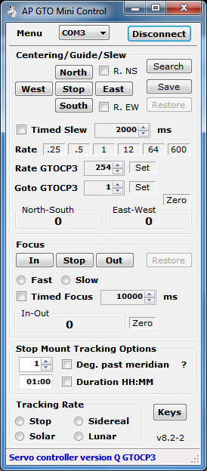

COM Serial Port
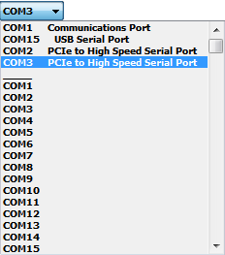

Selects the serial port used to communicate with the mount’s GTO Servo Controller.

Click on the COM port combo box to display a list of serial ports found on the computer. The list is divided into two sections. The top section show all the COM ports found on the computer with the Windows name associated with the port. The bottom section shows all possible COM ports. The selected COM port will be used when Connect is clicked.

Connect / Disconnect
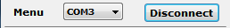

Opens and closes the serial port communicating with the mount’s GTO Servo Controller.

Connect – Button
Open serial port and start communications with the mount.
Sends the following two commands.
:U# and :V#
The first sets long format for RA and DEC the second requests the Servo Controller version. The type of GTO controller is then determined from the version returned. If it is determined the GTO controller is a GTOCP3 additional functions are enabled.
The Connect button will change to Disconnect and control functions will be enabled after connecting to the COM port of the mount.

Disconnect – Button
Closes serial port connected to mount
Will disable dome tracking if enabled.

Keys
Sets computer keyboard to control North, South, West, East, In and Out buttons.

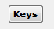
Not highlighted, computer keyboard not in control
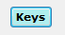
Highlighted, computer keyboard keys control mount functions listed above.

- Up Arrow – North button
- Down Arrow – South button
- Left Arrow – West button
- Right Arrow – East button
- PageUp Key – In Focus button
- PageDown Key – Out Focus button

Status Bar

Main windows status bar located at bottom of window.
Right click on status bar to clear the message.
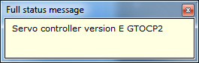

Left click to display message in a separate window. Useful for long or multiple lines messages.

Centering/Guide/Slew
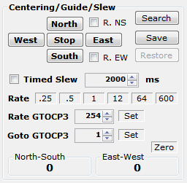

Controls movement of mount.
There is no way to query the mount and obtain the rates so when the program starts all rates are set at what the Hand Controller is set at.

North, South, West & East – Buttons
Moves the mount in the desired direction at the speed set by the Rate buttons with options selected below.

Timed Slew – Unchecked
Holding the direction button down will slew the mount in the desired direction. Releasing the button stops slewing.

Timed Slew – Checked
Click direction button to start timed slew in desired direction. Slew will stop after indicated number of ms (milliseconds, 1000 = 1 second) next to Timed Slew check box or when the Stop button is clicked.

R. NS – Check box
When checked will reverse the North and South buttons. (North will slew South and South will slew North) .

R. EW – Check box
When checked will reverse the East and West buttons. (East will slew West and West will slew East).

Rate – .25 .5 1 12 64 600
Click on desired number to select the North, South, West & East button slew rate. All rates are times sidereal. When a rate is selected the number button background will change color. The color can be set using Menu > Settings > Color > Set mouse hover colors…

Rate GTOCP3 – (GTOCP3 servo controller only)
Set between 1 and 256 to select the North, South, West & East button slew rate, then click Set. Button background will change to indicate rate has been set.

Search – Button
Opens the Search window to start and stop a expanding square area search.

Save – Button
Saves the mount’s current RA/DEC position then enables the Restore button.

Restore – Button
Slews the mount to RA/DEC position saved using the Save button. Unless another slew to RA/DEC has been issued after the Save. In this case the Restore slews to the last RA/DEC slew.

Goto GTOCP3 – (GTOCP3 servo controller only)
Set between 1 and 1200 to select the goto slew rate. This rate is used when slewing using RA/DEC and Altitude/Azimuth functions. This affects command received from both serial ports on the mount, so if another program is using the other serial port and issues a goto command the mount will slew using this set rate.

Zero – Button
Will zero the North-South and East-West counters. These counter indicate the time the mount has moved using the North, South, West & East buttons in milliseconds.

North-South – Counter
Milliseconds mount has moved using the North & South buttons. North is positive and South is negative.

East-West – Counter
Milliseconds mount has moved using the East & West buttons. East is positive and West is negative.

Focus
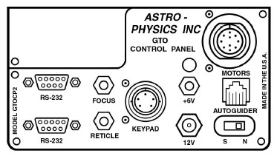

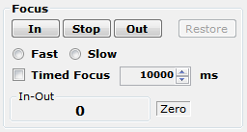

Controls a focus motor connected to the FOCUS connector on the GTO Servo Controller. Must be a 12VDC motor. The Meade 1201 Microfoucser will only work on a CP3 controller using Fast.

In, Out & Stop – Buttons
Moves focus motor in desired direction at speed set by Fast or Slow selection with options below.

Timed Focus – Unchecked
Hold the In or Out button down to move focus motor in desired direction. Release button to stop movement.

Timed Focus – Checked
Click In or Out button to start timed focus motor movement in desired direction. Movement will stop after indicated number of ms (milliseconds, 1000 = 1 second) next to Timed Focus check box or when the Stop button is clicked.

Restore – Button
If the In-Out counter is not zero will move the focus motor in the appropriate direction for the required time to zero the counter. This will bring the focus motor back to the beginning zero point.

Zero – Button
Will zero the In-Out counter. This counter indicates the time the focus motor has moved using the In and Out buttons in milliseconds.

in-Out – Counter
Milliseconds focus motor has moved using the In and Out buttons. Out is positive and In is negative.

Stop Mount Tracking Options
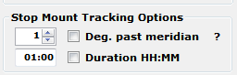

Stops mount’s tracking when certain conditions are met.

Deg. past meridian – Checked
Telescope is on the West side of the mount. Tracking will be stopped when the mount tracks past the meridian by the number of degrees indicated to the left of the check box. Valid values are 0 to 30. Each degree is equal to 4 minutes of tracking at sidereal rate.
Telescope is on the East side of the mount. Tracking will be stopped when the mount tracks 180° plus the number of degrees indicated or when the mount’s altitude is 5° from the horizon.

Note: If the meridian is adjusted using the mount’s hand controller you must take it into account when using this function.

Duration HH:MM – Checked
Tracking will be stopped after indicated duration.
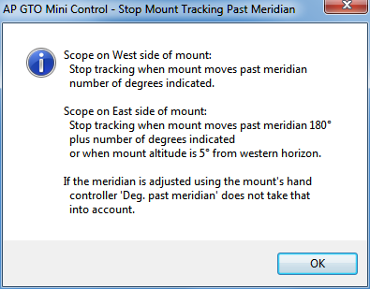
? – Help
Open the help window.

Tracking Rate
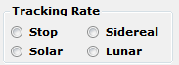

Tracking rate of mount.

Stop – Radio button
Stop tracking, sends :RT9# to mount. This stops the mount from moving.
Stop Mount Tracking can set this button.
Sidereal – Radio button
Set sidereal tracking rate, sends :RT@# to mount.
Solar – Radio button
Sets solar tracking rate, sends :RT1# to mount.
Lunar – Radio button
Sets lunar tracking rate, sends :RT0# to mount.

Menu > Main Menu
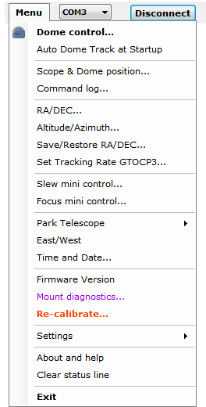

Shows the functions menu. Used to access other windows that perform additional functions.

Dome control…
Opens the Dome Control window for controlling NCO and AGF dome controllers. See section .

AutoDome Track at Startup
When checked the program will try to do the following so that automatic dome tracking will start without any operator inputs.
- Connect to mount’s GTO Servo Controller using current COM port.
- Get mount’s Altitude and Azimuth.
- Get the mount’s RA, DEC, Sidereal time, Side of mount, Latitude, Altitude and Azimuth.
- Connect to currently selected Dome Controller.
- Send INIT command to NCO dome controller if dome position is unknown. NCO Dome Controller only.
- Calculate dome azimuth.
- Move dome to calculated azimuth for NCO dome controllers. Set dome to calculated azimuth for AGF dome controllers (dome must be positioned to correct azimuth before starting the program).
- Enable automatic dome tracking.
If any of the above functions fail automatic dome tracking will not start and an error message is logged and displayed on the status line.

Scope & Dome position…
Opens the mount and dome position window. See section 7.

Command log…
Opens a window that show all commands sent and responses received from the mount along with any status and error messages generated by this program. See section 4.

RA/DEC…
Open the RA/DEC window to get or slew to an RA and DEC. See section 10.

Altitude/Azimuth…
Open the Altitude & Azimuth window to get or slew to an altitude and azimuth. See section 11.

Save/Restore RA/DEC…
Open the Save & Restore RA/DEC window to allow saving of RA, DEC and Name of anything. Can be saved and read from files with an extension of .oap. See section 5.

Set Tracking Rate GTOCP3…
Open the GTOCP3 Tracking windows to allow setting of custom tracking rates for both RA and DEC axis on mount’s with a GTOCP3 Servo Controller. Custom rates can be saved and read from a rate file with an extension of .tr3. See section 6.

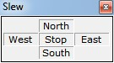
Slew mini control…
Opens a small window to move mount.

Focus mini control…
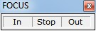
Opens a small windows to run the focus motor from the mount.

Park Telescope > Sub menu
Slew mount to one of three predetermined positions.
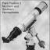
Position 1 Position 2 Position 3
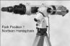


East/West
Show what side of the mount the telescope is on.
Sends :pS# to mount and displays one of the following on the status line in the Main window.
Side of pier telescope is positioned: East
Side of pier telescope is positioned: West

Time and Date…
Open the Time and Date window. Setting the time and date are only in effect until the mount is powered off. To make a permeate change you must use the Hand Controller. See section n.n.

Firmware Version
Gets the mount’s GTO Servo Controller version.
Sends :V# to mount and displays formatted result on the Main window status line.
The program looks at the returned version and tries to determine the model of the controller, GTOCP1, GTOCP2 or GTOCP3.
Servo controller version Q GTOCP3

Mount diagnostics…
Open the Mount Diagnostic window. Runs either the RA or DEC servo motors for x number of milliseconds with or without any delay. The motor is run in one direction then the other. This can be used to adjust an axis worm if needed. See section n.n.

Re-calibrate…
Performs the same function as the Hand Controller keys RA/DEC REV then 9. See section 14.
Must be used with caution!
Sends :CMR# to mount, result is displayed on Re-calibrate window status line. See section 14. Returns the following if successful.
Coordinates matched. #

About and help
Shows the about and help window. See section 15.

Clear status line
Clears the status line at the bottom of the main window.

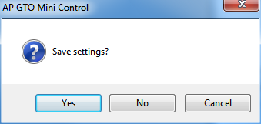
Exit
Opens a dialog message box for exit save setting and exit program options.
- Yes – Save setting and exit program.
- No – Do not save settings and exit program.
- Cancel – Continue running the program, does not exit.

Settings - Sub Menu
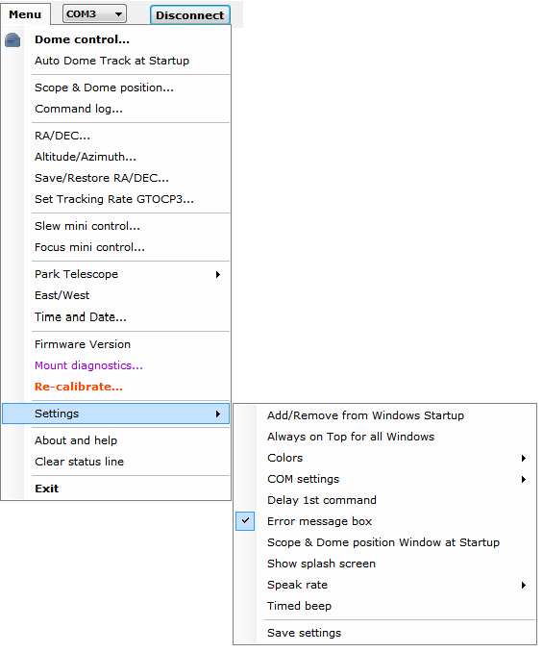

Additional program settings that are usually set once for user preferences.

Add/Remove from Windows Startup
Will add or remove settings to the Windows Registry to start AP GTO Mini Control when Windows is started. Main window status line will indicate if the program is added or removed from Windows startup.

Always on Top for all Windows
When checked all program windows will remain on top of other windows.

Color – Sub menu
Sets colors for button background and mouse hover. See section 3.2.

COM settings – Sub menu
Set serial COM port for mount settings. See section 3.3.

Delay 1st command
When checked will delay the very first command sent to the mount by 1 second. Only needed for some Bluetooth serial devices that are slow to connect.

Error message box
When checked will display a popup message box with additional error information in it for program and mount errors.

Scope & Dome position Window at Startup
When checked the Scope & Dome position will open when the program is started. See section 7.

Show splash screen
Redisplays the startup splash screen. Click on the picture to close.

Speak rate
Set speak rate for voice messages. See section 3.4.

Timed beep
When checked timed functions are enabled, moving with North, South, West, East, In & Out buttons a beep is given with the movement completes.

Save settings
Saves program settings to config file used during program startup.

Settings > Colors - Sub Menu
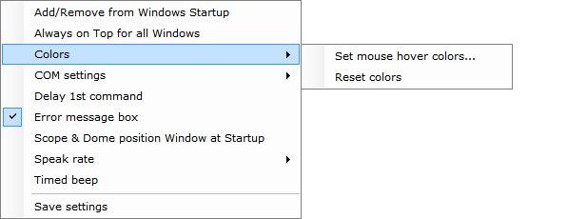

Sets or resets custom colors for mouse hover and motion buttons on the Main window.

Set mouse hover colors…
Opens the Windows color mixer window to set the color. The color will be used for button mouse hover color for the Rate and Zero buttons. The key down color for the North, South, West & East buttons and focus In and Out buttons. And the Keys button when active.

Reset colors
Resets the mouse hover and button down colors to program defaults.

Settings > COM settings – Sub menu
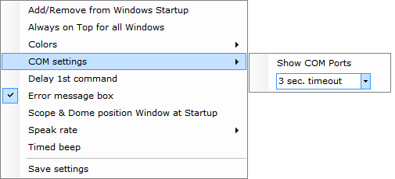

Settings for serial COM port that connects to the mount.

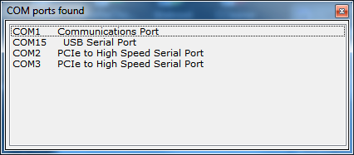

Show COM Ports
Shows window listing all COM serial ports found on the computer.
Double click on an entry to make it the current COM port. If already connected you must disconnect and then connect to open the newly selected COM port.

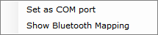

Right click on an entry to display the context menu.
Set as Com Port – Sets entry as the current COM port, same as double click.
Show Bluetooth Mapping – Displays the file AP Mini Bluetooth Serial Devices.txt located in the My Documents folder using Notepad. This file optional and must be created for each computer. Its purpose is to document specific Bluetooth configurations as a reference only.

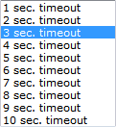

n sec. timeout – selection
Sets the COM port timeout value communicating with the mount. Values are from 1 to 10 seconds. Default is 3 seconds.

Settings > Speak rate – Sub menu
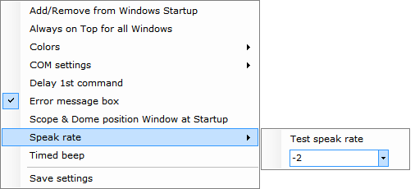

Sets speak rate for voice messages.

Test speak rate
Will speak a test message at the selected rate.
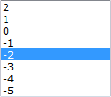
n
Speak rate from 2 to -5. Higher numbers will speak faster. Default is -2.

Command Log – Window
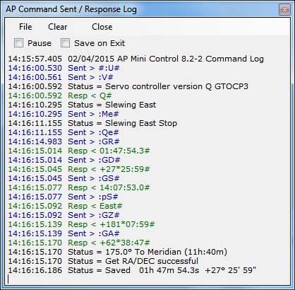

Shows status messages, error messages, commands sent and responses from the AP telescope mount.

All entries are time stamped and color coded.
- Black = Status and informational messages.
- Dark Red = Error messages.
- Blue = Commands sent to the dome controller.
- Green = Responses received from the dome controller.

Pause – Check box
When checked logging is suspended.

Save on Exit – Check box
When checked the log is saved to the My Documents folder with the name:
AP-Mini_Command_Log yyyy-mm-dd_time.rtf where yyyy = year, mm = month, dd = day, time = hours minutes seconds. Example: AP-Mini_Command_Log 2015-02-04_135125.rtf
The file is saved in Rich Text Format.

Clear – Menu button
Clears all log entries and starts a new log. The log is not saved.

Close – Menu button
Closes the log window.

File – Menu bar
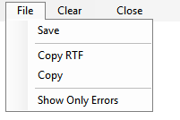
Log entries functions

Save – Button
Opens a file save dialog box to allow you to save the log to a file.

Copy RTF – Button
Copies all log entries to the clipboard in RTF (Rich Text Format).

Copy – Button
Copies all log entries to the clipboard in plain text format.

Show Only Errors – Button toggle
When checked will only show error entries in the log.

Save & Restore RA/DEC - Window
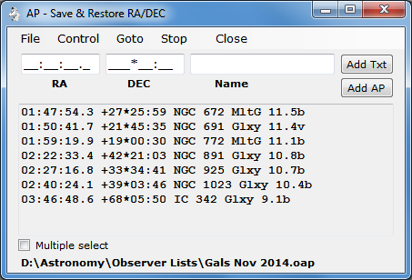

RA & DEC can be Named and saved to an .oap file.. The RA & DEC can be obtained from the mount or entered in the RA, DEC & Name text boxes.

RA – Text box
RA to add to the list format is HH:MM:SS.S the text box is formatted so you just enter the numbers.

DEC – Text box
DEC to add to the list format is +-DDD*MM:SS the text box is formatted so you just enter the sign and numbers.

Name – Text box
Any name you want to associate with the RA DEC entry.

Add Txt – Button
Add a new entry to the list using the RA, DEC & Name text boxes.

Add AP – Button
Add a new entry to the list using the mount’s current RA & DEC and the Name text box. Will query the mount for its RA & DEC.

RA DEC Name – List box
List of RA, DEC & Name entries added using the Add Txt and Add AP buttons for read from an .oap file.

Multiple select – Check box
When checked will allow multiple list box entries to be selected. This would be used to manage the list.

Status – Label
Displays status messages.

File – Menu
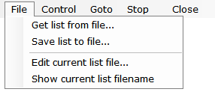

Save & Restore RA/DEC entries functions

Get list from file… – Button
Opens a file open dialog box to allow you to read a Save & Restore RA/DEC file.

Get list from file… – Button
Opens a file save dialog box to allow you to save the current RA, DEC, Name list to a file.

Edit current list file… – Button
Opens Notepad to edit the current RA, DEC, Name list file.

Show current list filename – Button
Displays the currently opened RA, DEC, Name list file on the status line.
RA, DEC, Name list files have the file type of .oap

Control – Menu
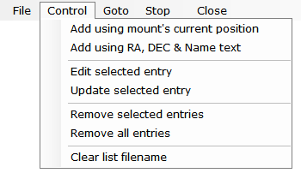

Controls entries in the Save & Restore RA/DEC list box.

Add using mount’s current position – Button
Add an entry to the list using the mount’s RA & DEC with then Name provided in the Name text box. Sends :GR# and :GD# commands to the mount.

Add using RA, DEC & Name text – Button
Add an entry to the list using the RA, DEC and Name text boxes.

Edit selected entry – Button
RA, DEC & Name text boxes are updated with the currently selected list entry.

Update selected entry – Button
Currently selected list entry is updated with the values in the RA, DEC & Name text boxes.

Remove selected entries – Button
Selected list entries are removed from the list.

Remove all entries – Button
All list entries are removed. List is cleared.

Clear list filename – Button
The saved RA/DEC filename is removed.

Menu Bar – Buttons

Buttons located on the menu bar.

Goto – Button
Slews the mount to the selected RA, DEC & Name list entry.

Stop – Button
Send a stop slew command to the mount.

Close – Button
Closes the window.

Context Menu – Popup
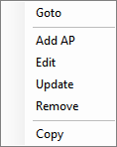

Menu is displayed when the Right Mouse Button is held down over a RA, DEC & Name entry.

Goto – Button
Slews the mount to the selected RA, DEC & Name list entry.

Add AP – Button
Add a new entry to the list using the mount’s current RA & DEC and the Name text box. Will query the mount for its RA & DEC.

Edit – Button
RA, DEC & Name text boxes are updated with the currently selected list entry.

Update – Button
Currently selected list entry is updated with the values in the RA, DEC & Name text boxes.

Remove – Button
Selected list entry is removed from the list.

Copy – Button
Copies the selected entry to the clipboard.

GTOCP3 Tracking - Window
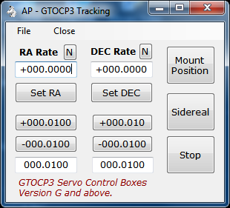

Set custom tracking rates for the RA and DEC axis of them mount.
Must be using a GTOCP3 Servo Motor Controller

RA Rate – Text box
Custom RA rate as +- times sidereal rate.

N – Button
Sets the RA Rate text box to zero.

Set RA – Button
Sends :RRsn.nnnn# command to the mount. Where rate is the value in the RA Rate text box.

+nnn.nnnn – Button (shows value of RA adjust text box)
Will increment the RA Rate text box by the value in the RA adjust text box.

-nnn.nnnn – Button (shows value of RA adjust text box)
Will decrement the RA Rate text box by the value in the RA adjust text box.

RA adjust – Text box
Value used with the increment and decrement RA button.

DEC Rate – Text box
Custom DEC rate as +- times sidereal rate.

N – Button
Sets the DEC Rate text box to zero.

Set DEC – Button
Sends :RDsn.nnnn# command to the mount. Where rate is the value in the DEC Rate text box.

+nnn.nnnn – Button (shows value of DEC adjust text box)
Will increment the DEC Rate text box by the value in the DEC adjust text box.

-nnn.nnnn – Button (shows value of DEC adjust text box)
Will decrement the DEC Rate text box by the value in the DEC adjust text box.

DEC adjust – Text box
Value used with the increment and decrement DEc button.

Mount Position – Button
Updates the Scope & Dome Position window with the mount’s current position. Opens the windows if not already open. See section n.

Sidereal – Button
Sets the mount’s RA axis to sidereal rate and stops the DEC axis from tracking. Sends commands :RR+1.0000# , :RD+0.0000# , :RT2# to the mount.

Stop – Button
Sets the mount to stop tracking. Sends commands :RR+1.0000# , :RD+0.0000#, :RT9# to the mount.

Close – Button
Closes the GTOCP3 Tracking window.

File – Menu
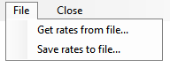

Read and save custom tracking rates to a file.
Custom tracking rate files have the file type of .tr3

Get rates from file… – Button
Opens a file open dialog box to read a custom rates file.

Save rates to file… – Button
Opens a file save dialog box to save the current custom rates to a file.

Scope & Dome Position – Window
Shows the mount and dome position in a window.
If dome tracking is enabled the window is updated automatically after querying the mount and dome controller.

Get – Button
Queries the mount and dome controller, if connected, and updates the window.

Go – Button
Opens the RA/DEC window to allow a goto RA/DEC to be done. See section 10.

The following data are shown:
- Ra: – RA from mount.
- Dec: - DEC from mount.
- Alt: - Altitude degrees from mount.
- Az: - Azimuth degrees from mount.
- Scope: - Side of pier telescope is on and distance to/from meridian information.
- Dome: Azimuth of dome. Only shown if dome controller is connected and tracking is enabled.
- Moved: Direction mount has moved since last update. Only shown if mount has moved to different RA/DEC and dome tracking is disabled.

Dome Control Window
Controls observatory domes using the NCO dome controller microprocessor or AGF dome controller. The NCO Controller is currently in use at the Nanjemoy Creek Observatory and controls the 16 foot ASH Dome. The AGF Controller is in use at the Milton Hill Observatory.
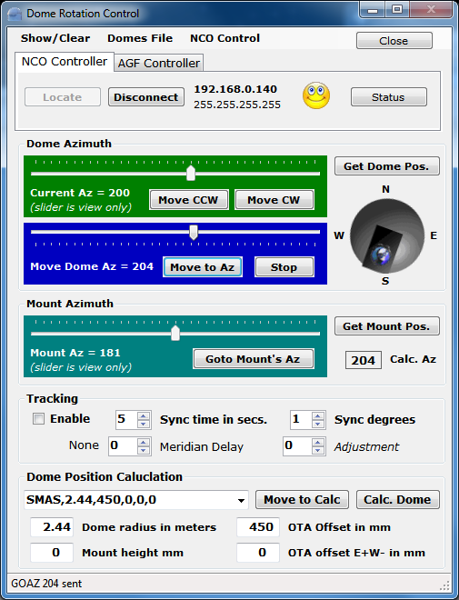

NCO Controller – Tab
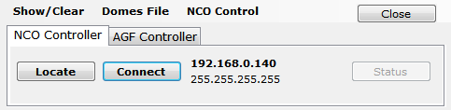

Must be selected to connect to a NCO dome controller. The NCO dome controller uses a standard Ethernet network TCP/IP V4 protocol to communicate.

Locate – Button
Sends a UDP packet to port 7778 and then listens for a response for 30 seconds. The response will have the IP address of the NCO dome controller which is then set to use with the Connect button.

Connect / Disconnect – Button


When Connect will start TCP/IP communications with the NCO dome controller using the IP address shown to the right of the button. The button will then change to Disconnect and will close the TCP/IP connection to the dome controller when clicked. The IP address and network mask can be set using the NCO Control menu. If the connect is successful a face icon will appear and cycle to indicate proper communications is going on.
IP address and network mask is shown to the right of the Connect / Disconnect button.

Status – Button
Shows dome controller status on status line at bottom of window. The first part of the status is what was sent back from the dome controller and the second part is the response formatted to display. Status is formatted as follows:
- OK 0 = Dome motor Off, OK1 = Dome motor On
- nn = Dome current azimuth
- nn = Dome goto azimuth
- 0 = No errors, 1 = RFID timeout, 2 = RFID not in table
- 0 = Emulator mode Off, 1 = Emulator mode On

Close – Button
Hides the window and will disable tracking if it is enabled. Does not disconnect from the dome controller.

AGF Controller – Tab
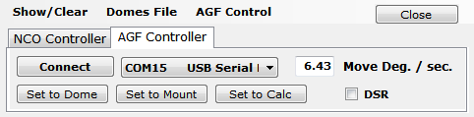

Must be selected when using an AGF Dome Controller for dome rotation.

Connect / Disconnect – Button
When Connect will open the serial COM port indicated in the combo box to the right of the button. Sends :V# to the AGF dome controller and displays the response in the status line at the bottom of the window. When Disconnect will close the COM serial port.

Move Deg. / sec. – Text box
Number of degrees the dome moves in 1 second. Will be determined by what dome motor and gear being used. Is also set using the Dome Position Calculation parameters.

COM – Combo box
Selects the serial COM port used to talk to the AGF dome controller. The top entries in the combo box show all COM serial ports found on the computer. The bottom part list all valid COM serial ports.

DSR – Check box
Check when using control signals on the DSR serial COM port to control the Enable dome tracking function. DSR COM port is set by using the AGF Control menu.

Set to Dome – Button *
Sets the dome position to match the Move Dome Az slider. Does not move the dome.

Set to Mount – Button *
Sets the dome position to match the Mount Az slider. Does not move the dome.

Set to Calc – Button *
Sets the dome position to the Calc. Az value. Does not move the dome.
* One of these buttons must be clicked to set the dome position before starting tracking.

Dome Azimuth – Controls
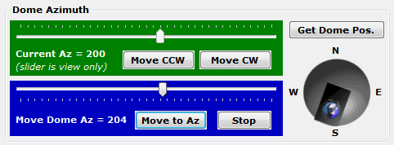

Manual movement of the observatory dome.

Current Az – Slider bar (read only)
Shows current dome azimuth.

Move CCW – Button
Click and hold to move dome Counter Clock Wise.

Move CW – Button
Click and hold to move dome Clock Wise.

Move Dome Az – Slider bar
Used to set the dome to any azimuth. Must click Move to Az to send command to the dome controller.

Move to Az – Button
Sends command to move dome to position set by Move Dome Az slider bar.

Stop – Button
Sends command to stop dome movement.

Get Dome Pos. – Button
Gets the current dome position from the dome controller and updates the Current Az slider and dome picture. For NCO dome controller only.

Dome graphic – Picture
Show the current dome position as obtained from the dome controller.

Mount Azimuth – Controls
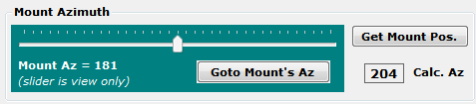

Telescope mount azimuth functions.

Mount Az – Slider bar (read only)
Shows the mount’s azimuth.

Goto Mount’s Az – Button
Sends command to dome controller to move dome to azimuth indicated in the Mount Az slider.

Get Mount Pos. – Button
Gets mount’s azimuth and updates Mount Az slider.

Calc. Az – Label
Shows the calculated dome azimuth by using the mount’s azimuth and Dome Position Calculation parameters given.

Tracking – Controls
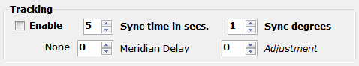

Dome tracking the telescope mount parameters.

Enable – Check box
When checked will start automatic dome tracking of the mount’s azimuth using the Calc. Az position.

Sync time in secs. – Number
Seconds between queries of mount and dome controller to determine if dome needs to be moved. Range is 1 to 10.

Sync degrees – Number
Number of degrees mount must move before the dome is moved to match the mounts azimuth. Range is 1 to 10.

Meridian Delay – Number
Hours East or West the meridian is delayed using the Astro-Physics Hand Controller. Dome tracking will be off if this does not match the Hand Controller. Text to left of number will indicate the amount and direction of the meridian delay. Range is 2 to +2.

Adjustment – Number
Number of degrees to add or subtract from the Calc Az to before a dome move is done. Most always set to 0. Range is -30 to +30.

Dome Position Calculation
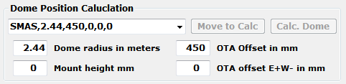

The geometry of the dome and telescope location on the mount are entered here and used in the Calc. Az function to determine the azimuth of the dome opening for a given dome and telescope combination.

Dome Mount Presets – Combo box
Presets can be edited with the Dome Files menu and are provided for the NCO and MHO observatories. Select SMAS,2.44,450,0,0,0 for NCO.
Preset entry format, separated by a comma:
- Name of preset, can be anything.
- Dome radius in meters.
- Distance from center of RA axis to center to telescope optical tube in millimeters.
- Distance East + or West – from the RA axis to the center of the telescope optical tube in millimeters.
- Height of mount RA axis to base of the dome. Has always been set to 0.
- AGF controller movement in degrees per second. Set to 0 for NCO controller.

Move to Calc – Button
Move the dome to the last Calc. Az position. Does not query the mount.

Calc. Dome – Button
Issues commands to the mount to get it’s position and then calculates where the dome should be positioned using data provided in the Dome Position Calculation. Does not move the dome. Updates Calc. Az.

Dome radius in meters – Text box
The radius of the observatory dome in meters.
OTA Offset in mm – Text box
Distance from center of RA axis to center to telescope optical tube in millimeters.

Mount height mm – Text box
Height of mount from base of dome in millimeters. Usually 0.

OTA offset E+W- in mm – Text box
Distance East + or West – from the RA axis to the center of the telescope optical tube in millimeters.

Status Line – Text

Displays status and error message from the dome control window.

Show/Clear – Menu
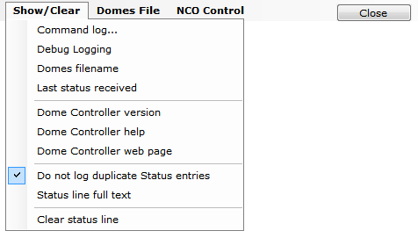
Common dome control functions and options.

Command log… - Button
Open dome controller command log window. See section 9.

Debug Logging – Button
When checked will provide additional information to the Command log showing parameters used to do the dome position calculation.

Domes filename – Button
Displays the current domes file being used on the status line.

Last status received – Button
Displays the last status request received from the NCO dome controller. Returns none for AGF dome controllers.

Dome Controller version – Button
Sends the command to get dome controller version and returns the result in the status line.

Dome Controller help – Button
Displays the NCO dome controller help web page from the controller.

Dome Controller web page – Button
Displays the NCO dome controller web page from the controller.

Do not log duplicate Status entries – Button
When checked if in tracking mode duplicate entries from polling the dome controller will not be entered into the dome command log.

Status line full text – Button
Displays a window that contains the status line’s full text. Used if status line is truncated or has multiple lines.

Clear status line – Button
Clears any text that is displayed in the status line.

Domes File – Menu
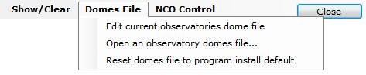

Observatory domes file management. Defines dome and telescope combinations for setting different configurations.

Edit current observatories dome file – Button
Opens the current domes file in Notepad for editing. The first part of the default file has comments documenting the format of the entries. Sample:
! AP GTO Mini Control Observatory Domes file
! Format is 3 values for each line separated by a comma
! Value 1 = Name of observatory (can be anything)
! Value 2 = Dome radius in meters
! Value 3 = Telescope ota offset from center of mount RA axis
! Value 4 = Telescope ota offset East + or West - from center of mount RA axis
! Value 5 = Mount height above dome base (can be negative)
! Value 6 = Dome rotation rate deg. / sec. (used only by AGF)
None,0.00,0,0,0,0
SMAS,2.44,450,0,0,0
MHO,1.15,445,0,0,6.43

Open a observatory domes file… - Button
Opens a file open dialog windows to allow a new domes file to be used.

Reset domes file to program install default – Button
Opens the domes file from the program install folder.

NCO Control - Menu
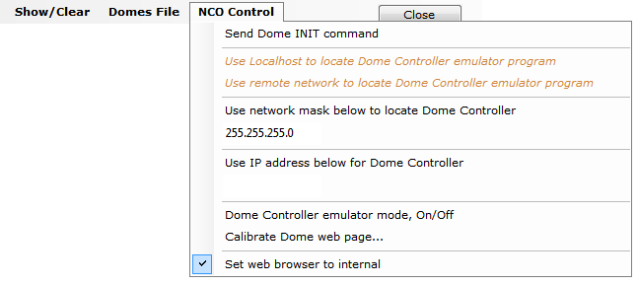
Settings to for the NCO dome controller.

Send Dome INIT command – Button
Sends INIT to the NCO dome controller, waits 6 seconds and returns the response.

Use Localhost to locate Dome Controller emulator program- Button
When checked will use this computer to find the NCO dome controller emulator program instead of the computer’s network. Uses network mask 127.0.0.255.

Use remote network to locate Dome Controller emulator program – Button
When checked will use the network interface being used by the computer to locate the NCO dome controller emulator program. Uses network mask 255.255.255.255.
Dome Controller emulator program is a software program that will emulate the NCO dome controller and must be installed separately. It is not currently available for download.

Use network mask below to locate Dome Controller – Button
When checked the network mask in the text box below this button will be used when the Locate button is clicked to send out the UDP packet to find the dome controller on the network.

Network mask – Text box
Any valid network mask. The default network mask is 255.255.255.255 for the entire network.

Use IP address below for Dome Controller – Button
When checked the IP address in the text box below this button will be used to connect to the NCO dome controller.

IP address – Text box.
TCP/IP address of the NCO dome controller on the network.

Dome Controller emulator mode, On/Off – Button
Will turn the NCO dome controller’s Emulator Mode On and Off. Button is checked when emulator mode is on. Sends command MODE 0 to turn off emulator mode and MODE 1 to turn on emulator mode.
Calibrate Dome web page… - Button
Connects to the NCO dome controller’s calibration web page.

Set web browser to internal – Button
When checked all web pages are displayed in a window from this program. When unchecked the computer’s default web browser is used to display web pages.

AGF Control – Menu
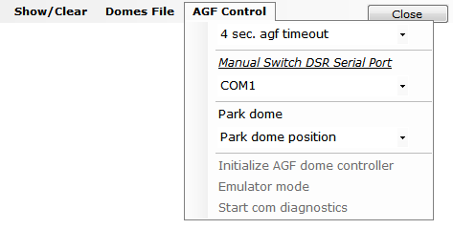

Settings for the AGF dome controller.

3 sec. agf timeout – Combo box
Time out for serial COM port connected to AGF dome controller. Values are from 1 to 5 seconds. Default is 3 seconds.

Manual Switch DSR Serial Port – Label
Label for serial COM ports combo box below used for a manual switch attached to the COM port to control, dome tracking and meridian delay.

COM – Combo box
Serial COM port that has the manual DSR switch connected to it. The top entries in the combo box show all COM serial ports found on the computer. The bottom part list all valid COM serial ports.

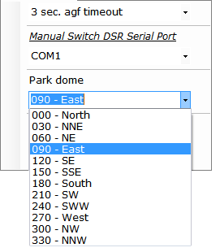
Park dome – Button
Will move the dome to the park position as selected in the Park dome position sub menu.

Park dome position – Combo box
Selects the dome park position to be used with the Park dome button. Values are 0 to 330 in 30 degree increments.

Initialize AGF dome controller – Button
Sends :I# to AGF dome controller to reset all relays. Returns Initialize pins 0-13 LOW.

Emulator mode – Button toggle
If unchecked sends :E1# to the AGF dome controller. This tells the dome controller not to move the dome but respond to normally to all dome movement command.
If checked sends :E0# to the AGF dome controller that turns off emulator mode.

Start com diagnostics – Button toggle
If unchecked will test the serial COM port connected to the AGF dome controller by sending a version request every 5 seconds. Also turns of Emulator mode.
If checked will stop the diagnostic and turn off Emulator mode.

Dome Command log – Window
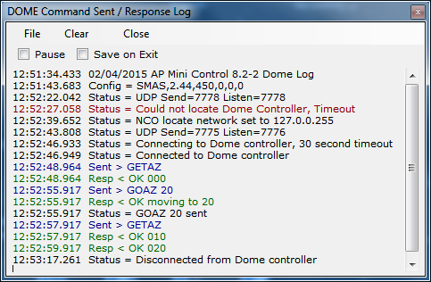

Shows status messages, error messages, commands sent and responses from the dome controller.
All entries are time stamped and color coded.
- Black = Status and informational messages.
- Dark Red = Error messages.
- Blue = Commands sent to the dome controller.
- Green = Responses received from the dome controller.

Pause – Check box
When checked logging is suspended.

Save on Exit – Check box
When checked the log is saved to the My Documents folder with the name:
AP-Mini_Dome_Log yyyy-mm-dd_time.rtf where yyyy = year, mm = month, dd = day, time = hours minutes seconds. Example: AP-Mini_Dome_Log 2015-02-04_135125.rtf
The file is saved in Rich Text Format.

Clear – Menu button
Clears all log entries and starts a new log. The log is not saved.

Close – Menu button
Closes the log window.

File – Menu bar
Log entries functions

Save – Button
Opens a file save dialog box to allow you to save the log to a file.

Copy RTF – Button
Copies all log entries to the clipboard in RTF (Rich Text Format).

Copy – Button
Copies all log entries to the clipboard in plain text format.

Show Only Errors – Button toggle
When checked will only show error entries in the log.

RA/DEC Window
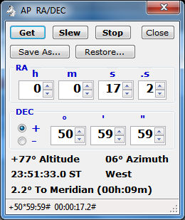
Control mount using RA & DEC and obtain mount’s position.

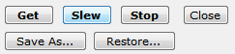
Functions – Buttons
Controls mount slewing and save / restore RA/DEC to a file.

Get – Button
Sends the following commands to the mount an formats the response to fill in the RA DEC number boxes and labels.
- :GR# - Get RA from mount.
- :GD# - Get DEC from mount.
- :GS# - Get Sidereal time from mount.
- :pS# - Get side of mount telescope is on.
- :GZ# - Get Azimuth from mount.
- :GA# - Get Altitude from mount.

Slew – Button
Slew mount to RA & DEC shown in the RA & DEC number boxes. Sends the following commands mount.
- :Sr hh:mm:ss.s# - Set RA (numbers filled from RA number boxes.) Returns 1 if success.
- :Sd +dd*mm:ss# - Set DEC (+ or – then numbers filled from DEC number boxes.) Returns 1 if success.
- : MS# - Slew the mount to set RA & DEC. Returns 0 if success.

Save As… – Button
Opens a save file dialog box to so the displayed RA/DEC can be saved to a file.

Restore… – Button
Opens an open file dialog box to read a saved RA/DEC file and the RA & DEC number boxes with the values saved in the file.

RA – Number boxes
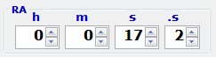

Displays the RA from the mount when the Get button is clicked.
Used to format the :Sr command when the Slew button is clicked.

h – Numeric
RA hours, range is 0 to 23.
m – Numeric
RA minutes, range is 0 to 59.
s – Numeric
RA seconds, range is 0 to 59.
.s – Numeric
RA tenths of seconds, range is 0 to 9.

DEC – Number boxes
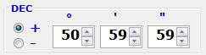

Displays the DEC from the mount when the Get button is clicked.
Used to format the :Sd command when the Slew button is clicked.

Sign – Radio buttons
Select + when DEC is positive.
Select - when DEC is negative.
° – Numeric
DEC degrees, range is 90 to 0.
‘ – Numeric
DEC minutes, range is 0 to 59.
“ – Numeric
DEC seconds, range is 0 to 59.

Mount Position – Text
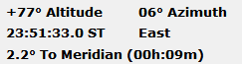

Shows the mount’s position when the Get button is clicked.

± nn° – Altitude.
nn° – Azimuth.
hh:mm:ss.s ST – Sidereal time.
East or West – Side of mount telescope is on.
nn.n° To or Past Meridian (nnh:nnm) – Degrees to or past meridian. If degrees are To the meridian also show time until meridian crossing in hour : minutes.

Status Line – Text

Shows status messages from the RA/DEC window.

Altitude/Azimuth Window
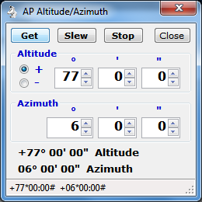
Control mount using Altitude & Azimuth and obtain mount’s Alt. Az. position.

Functions – Buttons

Controls mount slewing.

Get – Button
Sends the following commands to the mount an formats the response to fill in the Altitude & Azimuth number boxes and labels.
- :GZ# - Get Azimuth from mount.
- :GA# - Get Altitude from mount.

Slew – Button
Slew mount to Altitude Azimuth shown in the Altitude & Azimuth number boxes. Sends the following commands mount.
- :Sz ddd*mm:ss# - Set Azimuth (numbers filled from Azimuth number boxes.) Returns 1 if success.
- :Sa +dd*mm:ss# - Set Altitude (+ or – then numbers filled from Altitude number boxes.) Returns 1 if success.
- : MS# - Slew the mount to set Altitude & Azimuth. Returns 0 if success.

Altitude – Number boxes
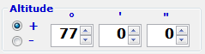

Displays the Altitude from the mount when the Get button is clicked.
Used to format the :Sa command when the Slew button is clicked.

Sign – Radio buttons
Select + when Altitude is positive.
Select – when Altitude is negative.
° – Numeric
Altitude degrees, range is 90 to 0.
‘ – Numeric
Altitude minutes, range is 0 to 59.
“ – Numeric
Altitude seconds, range is 0 to 59.

Azimuth – Number boxes
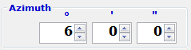

Displays the Azimuth from the mount when the Get button is clicked.
Used to format the :Sz command when the Slew button is clicked.

° – Numeric
Azimuth degrees, range is to 359.
‘ – Numeric
Altitude minutes, range is 0 to 59.
“ – Numeric
Altitude seconds, range is 0 to 59.

Mount Alt. Az. Position – Text
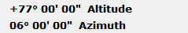

Shows the mount’s Altitude & Azimuth position when the Get button is clicked.

± nn° nn’ nn” – Altitude.
nn° nn’ nn” – Azimuth.

Status Line – Text

Shows status messages from the Altitude/Azimuth window.

Time and Date – Window
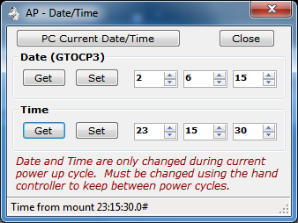

Set the Date and Time in the GTO Servo Controller.
This will set the date and time in the Servo Controller only. It does not affect the date and time in the Hand Controller, so a power cycle will not keep the settings set by this window. The date can only be set on a GTOCP3 servo controller.
PC Current Date/Time – Button
Fills in the Date and Time number boxes with the computer’s date and time.
Close – Button
Closes the Date/Time window.

Date (GTOCP3)
Get – Button
Sends :U# and :GC# to get the date from a GOPCP3 servo controller mount. The date is returned in the format MM/DD/YY#.
Set – Button
Sends :SCmm/dd/yy# to the mount with mm dd yy filled from the number boxes to the right. A response of 32 spaces, followed by a #, followed by 32 spaces, followed by a # is returned.
n – Number
Date month, 1 to 12.
n – Number
Date day, 1 to 31
n – Number
Date year, 0 to 99.

Time
Get – Button
Sends :U# and :GL# to get the local time from the servo controller in long format. The time is returned in the format HH:MM:SS.S#.
Set – Button
Sends :SLhh/mm/ss.0# to the mount with hh mm ss filled from the number boxes to the right. A response 1 is returned. Tenths of second is always set to 0 for this program.
n – Number
Time hour, 0 to 23.
n – Number
Time minutes, 0 to 59
n – Number
Time seconds, 0 to 59.

Status – Text
Displays status messages.

Diagnostics Adjustments – Window
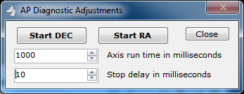

Runs the RA and DEC servo motors in forward then reverse direction with a delay between switching directions.
This can be used to adjust the worm gear of the RA or DEC axis of the mount.
Start DEC – Button
Begin DEC motor running forward, delay, reverse until clicked again. Button changes to Stop DEC when running.
Start RA – Button
Begin RA motor running forward, delay, reverse until clicked again. Button changes to Stop RA when running.
nnnn – Number
Axis run time in milliseconds. Motor is run this amount of time before a delay or change direction is issued. Range is 100 to 100000.
nnnn – Number
Stop delay in milliseconds. Delay between switching motor direction. Range is 0 to 10000.
Close – Button
Stops running both motors and closes the window.

Re-calibrate – Window
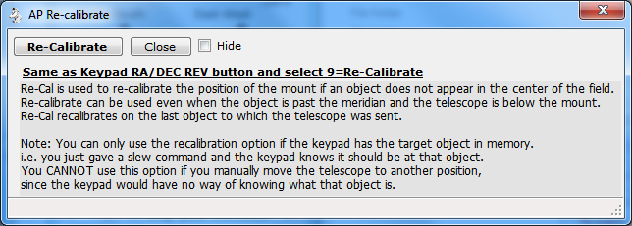
Warning window displayed when the Re-calibrate… Menu button is clicked on the Main window.

This performs the same function as pressing the hand controller keys RA DEC REV then 9.

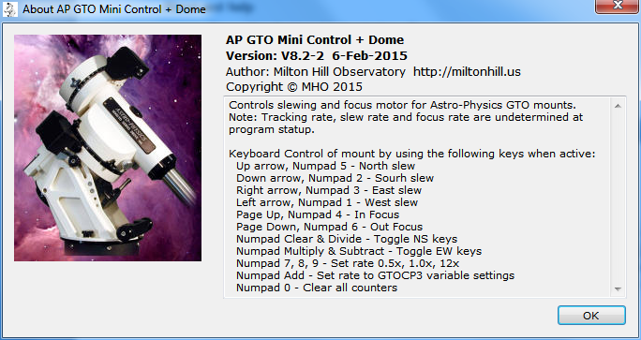
About and Help – Window

Installing, Starting and Stopping the System

Installing the system
Program distribution includes the following two files.
- setup.exe
- SetupWizard.msi
Run either file to install the software. If .NET Framework 2 is not found you will be asked to download and install it. A desktop icon shortcut and program group is created.

Upgrading from previous version
If AP GTO Mini Control is already installed on the computer is will be automatically uninstalled during the installation. You do not need to remove the program before re-installing it or installing a new version.

Starting the system
Click on desktop icon with the name AP Mini Control n.n-n or All Programs > Telescope Control > APGTO Mini Control vn.n-n. Where n.n-n is the current program version number.

Stopping the system
Click on the X button on the main window’s title bar.
Click on the main windows Menu > Exit button and click Yes on the popup message box. See section 3.

Uninstalling the system
Use Control Panel > Programs and Features to remove the program from the computer on Windows 7 & 8. For windows Xp use Control Panel > Add/Remove Programs.
The name of the program is AP GTO Mini Control.

Step by Step Instructions for using the system
This sections shows hardware connections needed and how to start the software.

Serial COM Port Connections to Mount
At least 1 Serial COM port is needed by the program to communicate with the telescope mount. This any device that supports RS-232 serial communication. See section 1.2 for a list of devices.
Use a ‘modem’ straight cable or device to connect on one of the two RS-232 serial connectors on the GTO Servo Controller module on the mount. The mount’s connectors are DB9 female.

NCO Dome Controller Connection
The NCO Dome Controller connects to a computer network via a RJ45 Ethernet connection.
The computer this program is running on must be able to access the network the NCO Dome Controller is connected to. See section 8.

AGF Dome Controller Connection
The AGF Dome Controller uses it’s Bluetooth or USB serial device to accept connections. A toggle switch selects which one will be used. See section 8.

Starting the Program
Double click on the desktop icon AP Mini Control or click AP GTO Mini Control under the Telescope Control start group to start the program.
If the setting Add/Remove from Windows Startup is checked the program will start when Windows starts. See section 3.1.
See section 18 for a quick start and usage guide.

Errors, Malfunctions, and Emergencies
Program errors can be shown in the following places:
- Status line of a window.
- Command log window.
- Dome Command log window.
- Popup message box.
- Visual Studio real time debug message box.
Some errors such as serial COM port timeouts to commands sent will generate an entry in a one of the log windows and operations will continue.

Quick-Reference for NCO Observatory
Use this sequence to do basic control of the telescope mount and dome tracking with the NCO dome controller when Auto Dome Track at Startup is disabled or fails.
This assumes all hardware connections to the mount and dome controller have been made.
- Power On the NCO dome controller and telescope mount.
- Power On the PC located on the left just inside the door.
- Start the program by double clicking desktop icon AP Mini Control.
- Normal operating mode is for Auto Dome Track at Startup to be enabled and the dome will begin tracking the telescope mount and no further action is required. If an error occurs during these operations you must either shutdown AP Mini Control and restart it or follow the steps listed below to begin dome tracking.
- Make sure the COM port showing is the one connected to the AP mount.
- Click on the Connect button.
- The status line will show Servo controller version x GTOCPn and the Connect button will change to Disconnect. If this does not happen do not continue.
- Click on Menu > Dome Control… to open the Dome Rotation Control window.
- The following is done using the Dome Rotation Control window.
- Select the NCO Controller tab.
- Check the NCO Control menu to make sure all Use … buttons are unchecked.
- Make sure the Dome Position Calculation preset is set to SMAS,2.44,450,0,0,0.
- If the IP address next to the Connect button is Unknown click the Locate button.
- Click the Connect button.
- A successful connection will show a changing face icon and the Status button will be enabled. If this does not appear you are unable to communicate with the NCO dome controller.
- Click the Enable check box under Tracking to begin dome to mount tracking. Warning the dome may move if its position is unknown.
- If the dome has not been moved by using remote control box in the observatory click the Move CCW or Move CW buttons until the dome picture updates. Note: The NCO dome controller does not know it’s position until it read an RFID tag. This is why this step may need to be done.
- Click the Calc. Dome button to calculate where the dome needs to be with the telescope in its current position.
- Check the Enable box under Tracking to being automatic dome tracking tied to the mount’s position.

Shutdown Procedure:
- When you are ready to shutdown everything just press the X on the title bar of the AP GTO Mini Control window. This will disable tracking, close the connections to the NCO dome controller and telescope mount, then save the current settings and exit.
- Power Off the PC.
- Use the AP hand controller at the telescope mount to park the mount. From the main menu select:
- 2=Setup
- 4=Park / Mount Opt.
- 3=Mount Park
- Wait for mount to stop moving.
- Power Off the telescope mount and NCO dome controller.

Appendix A – Reference Documents
The following documents are used in writing software program and this document:
Astro-Physics GTO Keypad Version v4.12 Appendix A and Appendix B
SMAS web site documents web page http://doc.smas.us/domecontrol/index.html

Appendix B – Glossary of Terms
Explain the meaning of all terms used in this document.
Term | Meaning
AP | Astro-Physics name of telescope mount manufacture.
MHO | Milton Hill Observatory, William Rison’s home observatory and name used to develop software.
NCO | Nanjemory Creek Observatory, SMAS observatory.
SMAS | Southern Maryland Astronomical Society.
GTOCP2 | Motor controller used in Astro-Physics telescope mounts, model 2.
GTOCP3 | Motor controller used in Astro-Physics telescope mounts, model 3 (latest).
GTO | Goto servo controller, one of the GTOCP controllers.

