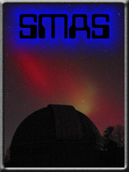
Nanjemoy Creek Observatory
Operators Manual
Version 0.1
05 January 2013

Contents
Observatory Lighting Controls 3
Safety Equipment 4
Observatory Operations 4
Powering up the Observatory 4
Dome Operation 5
Opening the Dome Shutter 5
Dome Positioning 6
Celestron C14 Telescope 6
Spotting Scope 6
Guide Scope 6
Guide Camera 7
Using PHD Guiding 7
Automatic Calibration 7

Figure 1: White Light Switch 3
Figure 2: Stairway Red Light Controls 3
Figure 3: Upper Red Light Control Box 4
Figure 4: Fire Extinguisher 5
Figure 5: Observatory Power Control Panel 5
Figure 6: Dome Shutter Power Connection 6
Figure 7: Dome Shutter Controls 6
Figure 8: Dome Position Controls 7

Introduction
This manual is intended for the use by members of the Southern Maryland Astronomical Society Nanjemoy Creek Observatory. The primary audience is the newer member who may not be familiar with the operation of the equipment in the observatory. This is not intended to be an astronomy primer.

Observatory Lighting Controls
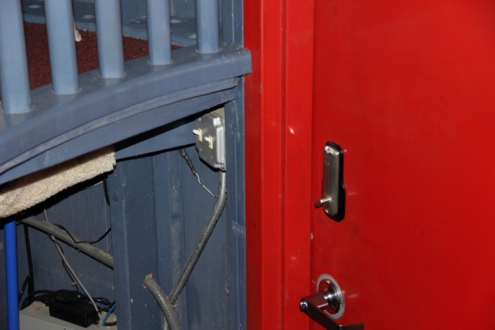
Figure 1: White Light Switch
When you enter the observatory there is a light switch that controls the observatory white lights on your right. The white light brightness can be controlled by a dimmer switch that is located on the north wall. It is not recommend turning on these lights when people are using the observatory.

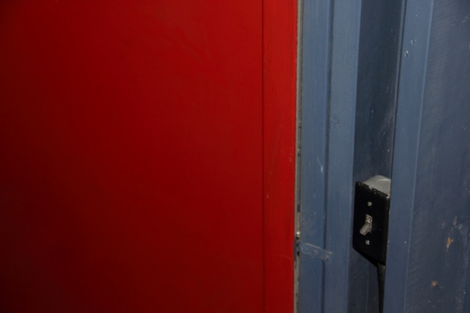
Figure 2: Stairway Red Light Controls
On the left side of the observatory door is a light switch that controls the red lights on the staircase. These lights should be turned on anytime the observatory is in use after dark.

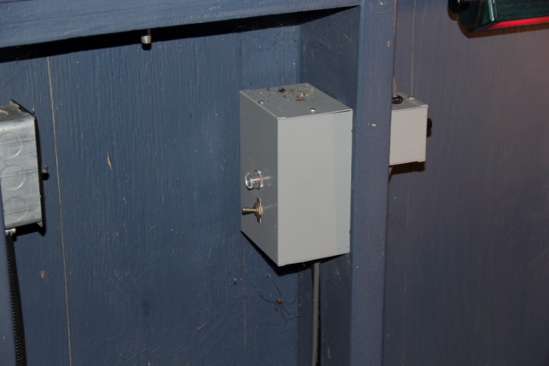
On the west wall there is a small box that controls the red lights on the upper level of the observatory. Figure 3 shows the control box with the switch in the on position. Each of the red lights has a dimmer switch that can be used to control the brightness.
Figure 3: Upper Red Light Control Box

Safety Equipment

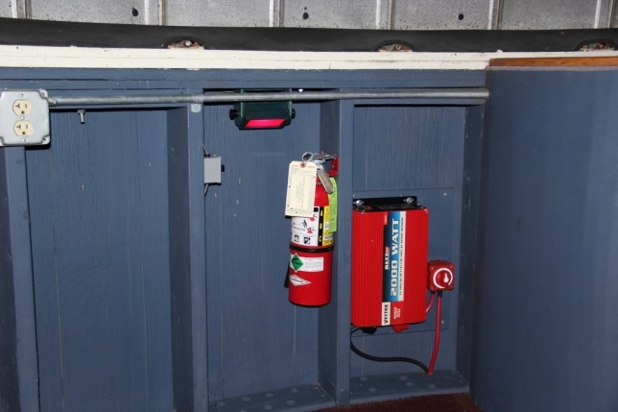
A fire extinguisher is located on the south wall of the observatory. Hopefully you will never need this.
Figure 4: Fire Extinguisher
The inverter and battery switch are used to open or close the hatch if ac power is lost. See appendix for its operation.

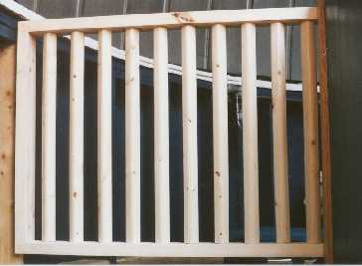
Figure 5: Stair safety gate

A safety gate is located at the top of the stairway. You should close the gate while working on the upper level in the dark.

Observatory Operations
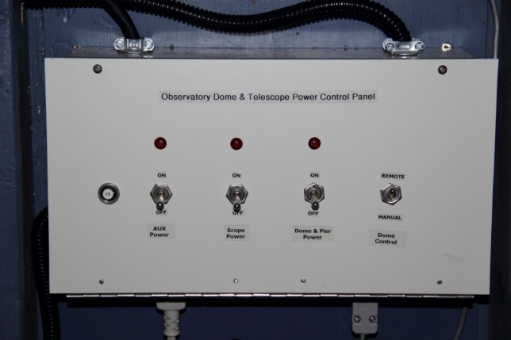
The following sections cover operating the equipment in the observatory. This will be broken into 3 sections. The first section will be operating the equipment from within the observatory; the second section will cover remote control of the observatory equipment from the control room; the final section will cover shutting down the observatory.

Powering up the Observatory
Prior to operating the observatory equipment you will need to turn on the power for various components. The observatory power control panel is located on the south wall of the observatory. This panel is used to control power to the telescope pier, mount and the dome. The control panel also has a switch to control how the dome position commands are performed, manually or automatically.
Figure 6: Observatory Power Control Panel
The observatory power control panel has 4 switches.
Aux Power – Spare currently ont used.
Scope Power – This switch controls power to the telescope and associated equipment.
Dome and Pier Power – This switch controls power to the dome controller, dome rotation motor and the telescope pier.
Dome Control – When this switch is in the up position, control of the dome is performed manually using the dome position lever. When this switch is in the down position the control of the dome is performed remotely from the control room, or with the hand control located at the pier. The dome is also able to be slaved to the telescope mount. In this mode, the telescope is slewed to the object to be observed and when the mount completes is positioning, the dome will automatically move to a position that has the dome slot lined up with the telescope.
Turn on power for the telescope and dome by placing the switches in the up position.

Dome Operation
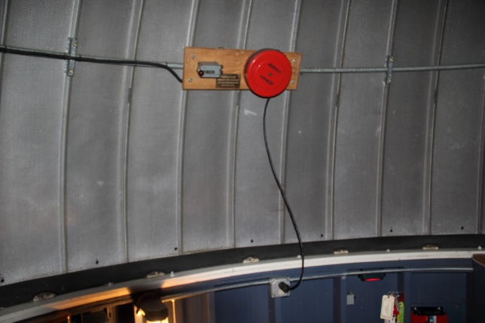
Dome operations consist of opening the shutter, dome pointing and securing the dome when your observation session is over.

Opening the Dome Shutter
The dome shutter requires 110VAC to operate. Pull the power cord out and connect it to the AC outlet that is located below the control box. The shutter has 2 panels, an upper and lower. The lower panel can be opened if you are viewing items low on the horizon. For normal operations, and when you need to observe objects directly overhead, you will want to leave the lower panel in its closed position. Pull the cord on the shutter lock mechanism to separate the upper and lower shutter panels. There is a catch slot on the lower left hand side of the shutter. Place the panel separator cord in this slot after you have disengaged the two panels to avoid the cord being caught on objects as the dome is rotated.
Figure 7: Dome Shutter Power Connection
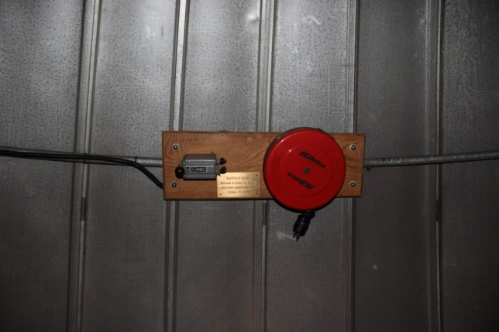
To open the shutter, rotate the shutter control lever up. The shutter will begin to open (you will hear it creaking, that’s normal). The shutter motor will stop once the shutter is completely open. Rotate the shutter control lever down to the middle position once the shutter is open. There is no requirement to have power applied to the shutter controls once it is open. Unplug the shutter control and let the power cord retract into the cord holder.
Figure 8: Dome Shutter Controls
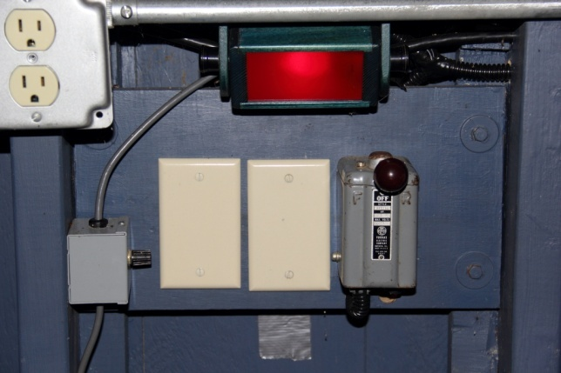

Dome Positioning
The dome can be manually rotated in either direction. Use the hand control (located on the pier) to move the dome. The Dome control switch must be in the Remote position. Pressing the CW button moves the dome in the clockwise direction, pressing the CCW button moves the dome in the counterclockwise direction. Note there is a 2 second delay when changing direction. Also the dome can be controlled by using the control box located on the west wall of the observatory. When the Dome control switch is in the Manual position, moving the lever to the right will rotate the dome clockwise, to the left will move the dome counterclockwise.
Figure 11: Dome Position Controls
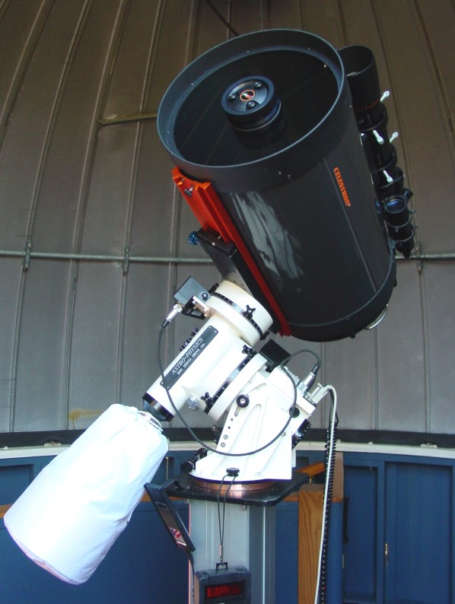

Celestron C14 Telescope
The primary telescope is the Celestron C14. The scope also includes an 80mm spotting scope and a 50mm autoguide scope. Remove the lens covers from the main, and spotting scope. If you are going to use the guide scope, you will want to remove the lens covers from this scope also.
The C14 is equipped with multiple focusers. The primary focuser is the standard SCT focuser on the back of the telescope. This focuser functions by moving the primary mirror up and down to achieve focus.
A Starlight Instruments Feather Touch focuser is connected to the visual back of the telescope. This allows manual focus control for visual and imaging sessions.
Figure 9: C14

Spotting Scope
The spotting scope is the Celestron 80mm. You will need to install an eyepiece prior to use. Eyepieces are located in the wood case in the cabinet of the control room. A 26mm eyepiece works well in the spotting scope.

Guide Scope
The guide scope is a 50mm scope attached to the C14. The guild camera is inserted in to the guide scope. The guide camera has a parafocal ring installed to maintain focus when used with the guide scope.

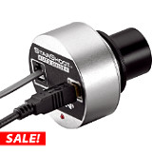
Guide Camera
Autoguiding can be performed with the use of the Orion Starshoot autoguider camera. The autoguider requires a connection to a computer which takes camera data and determines what corrections are required to keep the mount tracking accurately. The computer should have software installed that processes the data from the guide camera. The computer in the control room had]s PHD (Push Here Dummy) installed for use with the autoguider. PHD is free software and you can download and install from www.stark-labs.com.
Figure 10: Autoguide Camera

Using PHD Guiding
There are six basic steps to start guiding.
- Press the Camera Button and select your camera **
- Press the Scope Button and select your telescope mount
- Pick an exposure duration from the drop-down list
- Hit the Loop Button and adjust your focus. Move the mount or adjust the exposure duration as needed to find a suitable guide star. Then, optionally, hit Stop.
- Click on a star that's not very near an edge. After you do this, you'll see a green box appear surrounding the star. Note, if you pick a star that is too bright, a dialog will appear telling you the star is "saturated" and that odds are you should either use another star or decrease the exposure duration to keep it from being so over-exposed.
- Press the PHD Guide button.
** Shift-click will connect to the last-used camera.

Automatic Calibration
When you do that last step, the calibration process will begin. Yellow cross-hairs will appear over the original location of your guide star and PHD Guiding will start to move the mount in various directions, tracking how the star moves as a function of what move commands were sent to the mount.
Once the calibration is done, the cross-hairs will turn green and guiding will begin automatically. To stop guiding (e.g., if you want to move your mount to another target), simply hit the Stop button. When you're ready to start guiding again, select a star (Loop again if necessary) and hit the PHD Guide button. The calibration will not be re-run unless you request
For more details on autoguiding and using PHD see the tutorial section at www.stark-labs.com.

