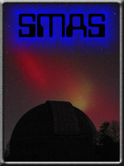
Nanjemoy Creek Observatory
Operators Manual
Version 0.1
05 January 2013

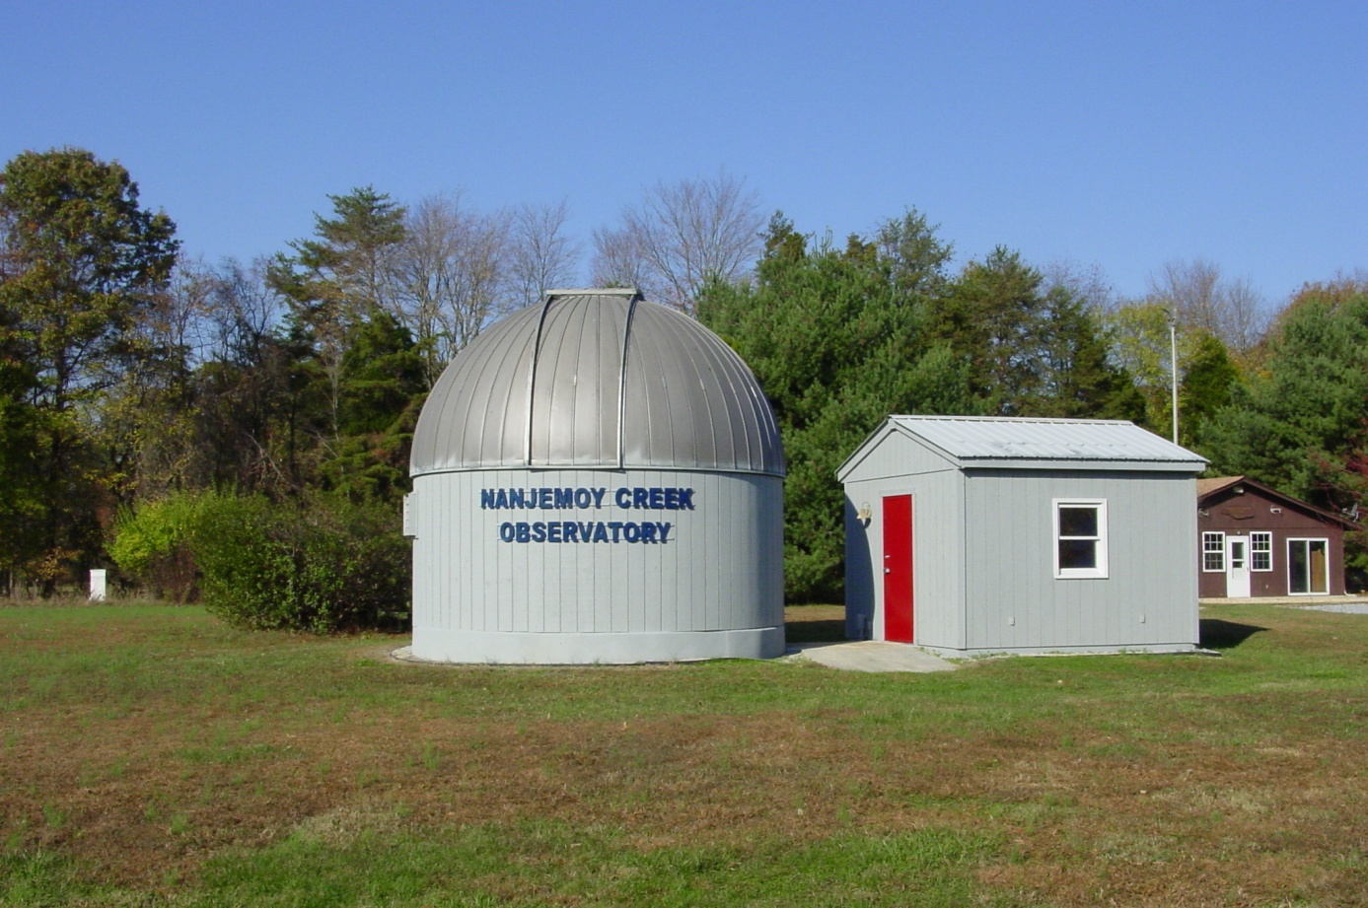

Contents
Introduction 4
Observatory Lighting Controls 5
Safety Equipment 6
Observatory Operations 7
Powering up the Observatory 7
Dome Operation 8
Opening the Dome Shutter 8
Dome Positioning 9
Emergency Dome Power 9
Celestron C14 Telescope 10
Spotting Scope 10
Guide Scope 10
Pier 10
Guide Camera 11
Using PHD Guiding (This section on loan from www.stark-labs.com) 11
Automatic Calibration 11
Control Room 12
Remote Operations 12
Remote Dome Control 12
Remote focuser Control 12

Figure 1: White Light Switch 3
Figure 2: Stairway Red Light Controls 4
Figure 3: Upper Red Light Control Box 4
Figure 4: Fire Extinguisher 5
Figure 5: Stair saftey gate 5
Figure 6: Observatory Power Control Panel 6
Figure 7 Dome Hatch 7
Figure 8: Dome Shutter Power Connection 7
Figure 9: Dome Shutter Controls 7
Figure 10: Dome Position Controls 8
Figure 11: C14 9
Figure 12 Pier Hand control (need better image) 9
Figure 13: Autoguide Camera 10

Introduction
This manual is intended for the use by members of the Southern Maryland Astronomical Society. The primary audience is the newer member who may not be familiar with the operation of the equipment in the observatory. This is not intended to be an astronomy primer.
As a member of SMAS, you are entitled to use the observatory located at the Nanjemoy Creek Environmental Education Center (NCEEC) facility. With this privilege come certain responsibilities that are listed below, but first, you must be given a site tour by an authorized member, such as the President or Program Coordinator. Since the observatory is located on a Charles County Board of Education facility, we must also abide by their wishes.
The following procedures are to be used when accessing the site during non SMAS events. SMAS events are the club observing sessions and any public or private star parties.
- Check the SMAS calendar to see if the site if free to use.
- Check the club's SOMDAS Yahoo group to see if anyone else has priority on using the observatory scope.
- Leave a message on SOMDAS stating you are going to be using the observatory or going to the site.
- Call NCEEC at 301-743-3526 and leave a message on the answering machine. Include your name, a contact number, and the fact that you are a SMAS member who will be coming to use the observatory site. The NCEEC facility has overnight classes during the school year, so it very important to call them before your visit.
- The NCO phone number is also 301-743-3526. This number can be used to contact SMAS members in the control building, if they are inside to answer the phone.

Observatory Lighting Controls

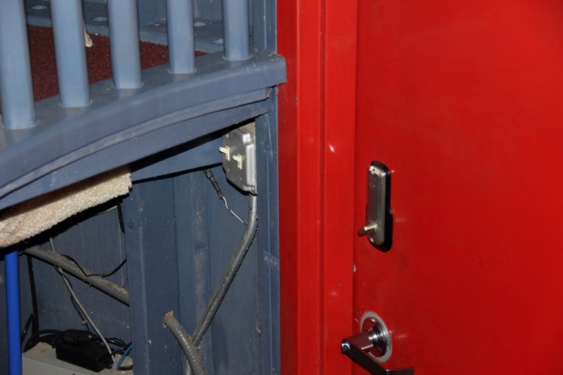
Figure 1: White Light Switch
When you enter the observatory there is a light switch that controls the observatory white lights on your right. The white light brightness can be controlled by a dimmer switch that is located on the north wall. It is not recommend turning on these lights when people are using the observatory.

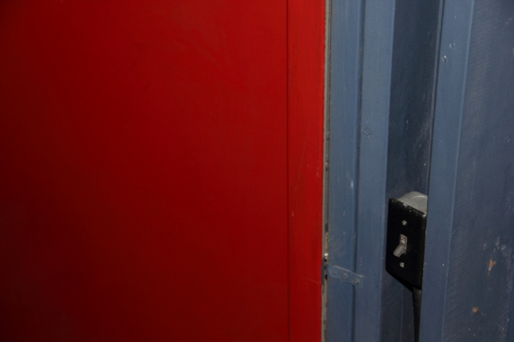
Figure 2: Stairway Red Light Controls
On the left side of the observatory door is a light switch that controls the red lights on the staircase. These lights should be turned on anytime the observatory is in use after dark.

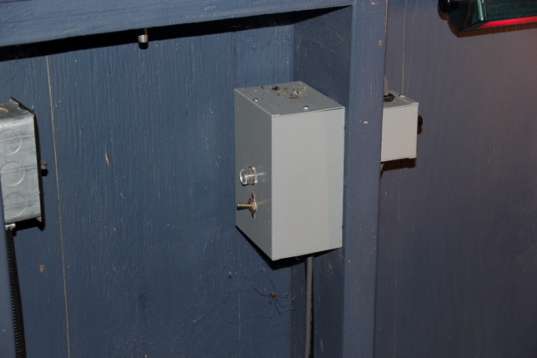
On the west wall there is a small box that controls the red lights on the upper level of the observatory. Figure 3 shows the control box with the switch in the on position. Each of the red lights has a dimmer switch that can be used to control the brightness.
Figure 3: Upper Red Light Control Box

Safety Equipment

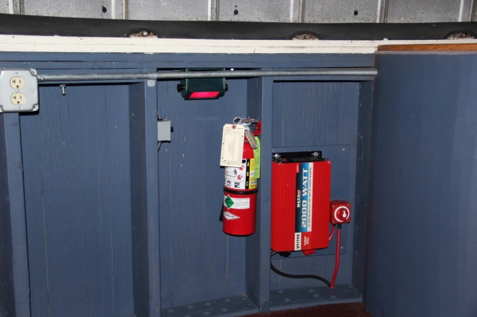
A fire extinguisher is located on the west wall of the observatory. Hopefully you will never need this.
Figure 4: Fire Extinguisher

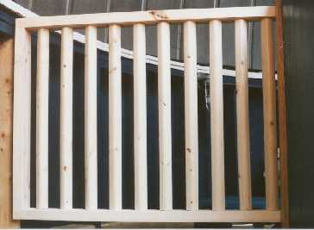
Figure 5: Stair saftey gate

A safety gate is located at the top of the stairway. You should close the gate while working on the upper level in the dark.

Observatory Operations
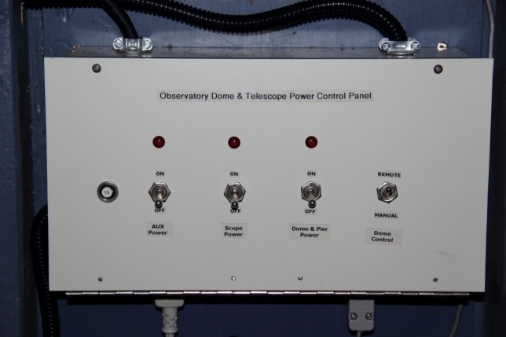
The following sections cover operating the equipment in the observatory. This will be broken into 3 sections. The first section will be operating the equipment from within the observatory; the second section will cover remote control of the observatory equipment from the control room; the final section will cover shutting down the observatory.

Powering up the Observatory
Prior to operating the observatory equipment you will need to turn on the power for various components. The observatory power control panel is located on the south wall of the observatory. This panel is used to control power to the telescope pier, mount and the dome. The control panel also has a switch to control how the dome position commands are performed, manually or automagicly.
Figure 6: Observatory Power Control Panel
The observatory power control panel has 4 switches.
Aux Power – I have no idea what this controls.
Scope Power – This switch controls power to the telescope and associated equipment.
Dome and Pier Power – This switch controls power to the dome, dome shutter motors and the telescope pier.
Dome Control – When this switch is in the up position, control of the dome is performed manually using the dome position lever. When this switch is in the down position the control of the dome is performed remotely from the control room. The dome is also able to be slaved to the telescope mount. In this mode, the telescope is slewed to the object to be observed and when the mount completes is positioning, the dome will automagicly move to a position that has the dome slot lined up with the telescope.
Turn on power for the telescope and Dome by placing the switches in the up position.

Dome Operation
Dome operations consist of opening the shutter, dome pointing and securing the dome when your observation session is over.

Opening the Dome Shutter
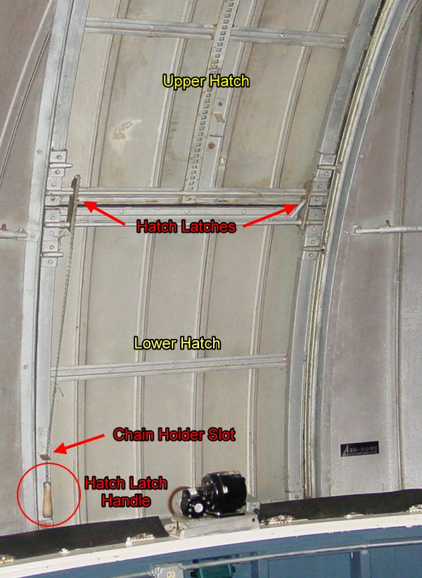
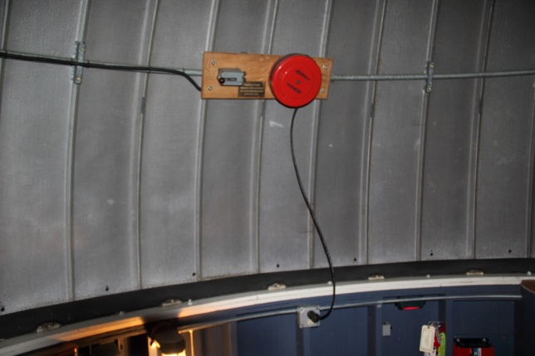
The dome shutter requires 110VAC to operate. Pull the power cord out and connect it to the AC outlet that is located below the control box. The shutter has 2 panels, an upper and lower. The lower panel can be opened if you are viewing items low on the horizon. For normal operations, and when you need to observe objects directly overhead, you will want to leave the lower panel in its closed position. Pull the cord on the shutter lock mechanism to separate the upper and lower shutter panels. There is a catch slot on the lower left hand side of the shutter. Place the panel separator cord in this slot after you have disengaged the two panels to avoid the cord being caught on objects as the dome is rotated.
Figure 7 Dome Hatch
Figure 8: Dome Shutter Power Connection

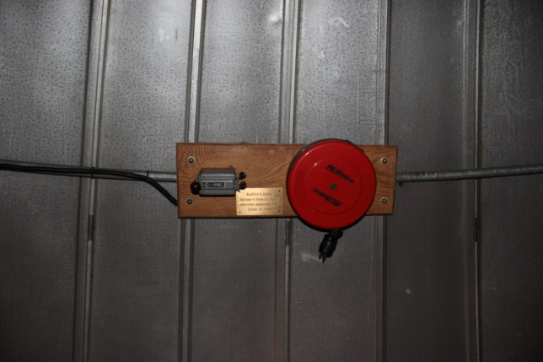
To open the shutter, rotate the shutter control lever up. The shutter will begin to open (you will hear it creaking, that’s normal). The shutter motor will stop once the shutter is completely open. Rotate the shutter control lever down to the middle position once the shutter is open. There is no requirement to have power applied to the shutter controls once it is open.
Figure 9: Dome Shutter Controls
Unplug the shutter control and let the power cord retract into the cord holder.
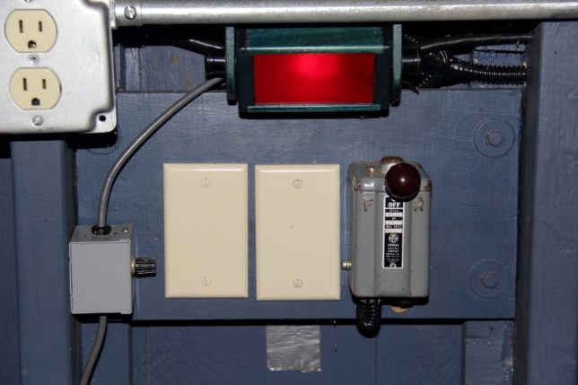

Dome Positioning
The dome can be manually rotated in either direction. The dome position control box is located on the southern wall of the observatory. When the Dome control switch is in the manual position, moving the lever to the right will rotate the dome clockwise, to the left will move the dome counterclockwise.

Emergency Dome Power
Figure 10: Dome Position Controls
The observatory is equipped with a battery backup power source for closing the dome in the event of a power failure.
Someone please help complete this section.

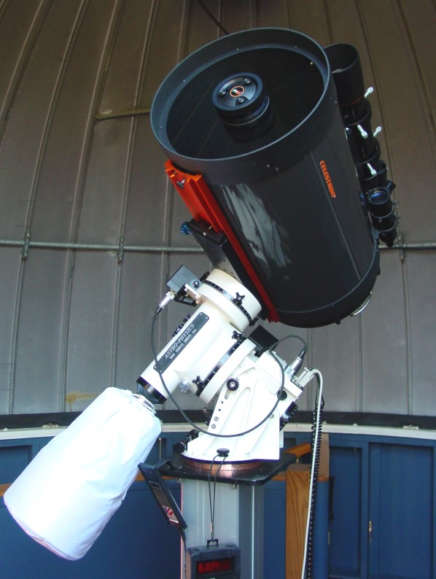

Celestron C14 Telescope
The primary telescope is the Celestron C14. The scope also includes an 80mm spotting scope and a 50mm autoguide scope. Remove the lens covers from the main, and spotting scope. If you are going to use the guide scope, you will want to remove the lens covers from this scope also.
The C14 is equipped with multiple focusers. The primary focuser is the standard SCT focuser on the back of the telescope. This focuser functions by moving the primary mirror up and down to achieve focus.
A Starlight Instruments Feather Touch focuser is connected to the visual back of the telescope. This allows manual focus control for visual and imaging sessions.
Figure 11: C14

Spotting Scope
The spotting scope is the Celestron 80mm. You will need to install an eyepiece prior to use. Eyepieces are located in the wood case in the cabinet of the control room. A 26mm eyepiece works well in the spotting scope.

Guide Scope
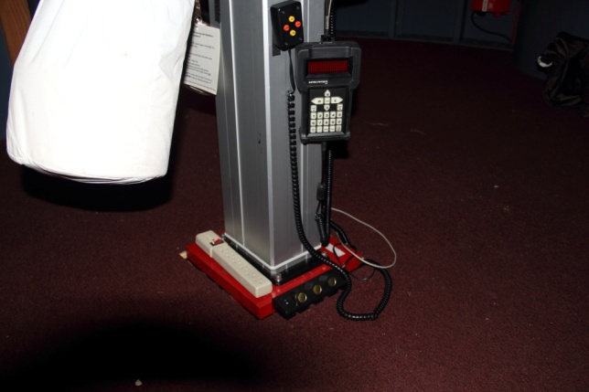
The guide scope is a 50mm scope attached to the C14. The guild camera is inserted in to the guide scope. The guide camera has a parafocal ring installed to maintain focus when used with the guide scope.
Figure 12 Pier Hand control (need better image)

Pier
The pier can be raised and lowered using the hand control

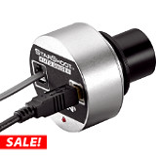
Guide Camera
Autoguiding can be performed with the use of the Orion Starshoot autoguider camera. The autoguider requires a connection to a computer which takes camera data and determines what corrections are required to keep the mount tracking accurately. The guiding computer requires the Starshoot autoguider device driver and should have software installed that processes the data from the guide camera. The device driver and the PHD software is on the Starshoot CD which is located ????. The computer in the control room has the driver and PHD (Push Here Dummy) installed for use with the autoguider. PHD is free software and you can download and install from www.stark-labs.com.
Figure 13: Autoguide Camera

Using PHD Guiding (This section on loan from www.stark-labs.com)
There are six basic steps to start guiding.
- Press the Camera Button and select your camera **
- Press the Scope Button and select your telescope mount
- Pick an exposure duration from the drop-down list
- Hit the Loop Button and adjust your focus. Move the mount or adjust the exposure duration as needed to find a suitable guide star. Then, optionally, hit Stop.
- Click on a star that's not very near an edge. After you do this, you'll see a green box appear surrounding the star. Note, if you pick a star that is too bright, a dialog will appear telling you the star is "saturated" and that odds are you should either use another star or decrease the exposure duration to keep it from being so over-exposed.
- Press the PHD Guide button.
** Shift-click will connect to the last-used camera.

Automatic Calibration
When you do that last step, the calibration process will begin. Yellow cross-hairs will appear over the original location of your guide star and PHD Guiding will start to move the mount in various directions, tracking how the star moves as a function of what move commands were sent to the mount.
Once the calibration is done, the cross-hairs will turn green and guiding will begin automatically. To stop guiding (e.g., if you want to move your mount to another target), simply hit the Stop button. When you're ready to start guiding again, select a star (Loop again if necessary) and hit the PHD Guide button. The calibration will not be re-run unless you request
For more details on autoguiding and using PHD see the tutorial section at www.stark-labs.com.

Control Room

Remote Operations
List of what can be remote controlled. Limitations of remote operations (not over the internet yet).

Remote Dome Control
Required software
Operation

Remote focuser Control
Required software
Operation

