How to restore a Windows computer from a snapshot backup image.

Snapshot (drive snapshot) is a disk imaging program for creating and restoring Microsoft Windows systems and disks. The backup images along with the snapshot program are kept on an external usb hard drive.

SMAS NCO computers consist of two main systems SMAS1 and AllSky PC’s.

Currently 2019 the SMAS1 computer is setup to dual boot Windows 10 and Windows 7, they are on two separate hard drives. However the boot loader is from one drive that asks what system to boot, the default is Windows 10. This has a GigaByte GA-H81MHD3 Rev2 motherboard.

The AllSky computer is a Shuttle DS81 and uses Windows 7. This computer has two SSD drives the system boot drive being an mSATA card that plugs into the motherboard. The other drive is a 2.5 inch SSD that keeps all the camera images and data.

Backups are kept on an external hard drive located on the book shelves in the CD’s cardboard box. This disk is NOT bootable. Also in that box are the Windows 10 and 7 installation boot DVD’s along with a Windows 10 USB installation thumb drive. This is used to boot when restoring both Windows 7 and 10. It is only needed if the systems won’t boot or you are updating the system disk with a new one.

The easiest way to restore a system that can be booted and is running is to run “snapshot” from Windows and over write the system. This is outlined in the SNAPSHOT WINDOWS section.

If the system won’t boot or you are replacing the boot drive; use the STANDALONE RESTORE procedure. If you know how to get to the command prompt you can jump to the COMMAND WINDOW section.

STANDALONE RESTORE

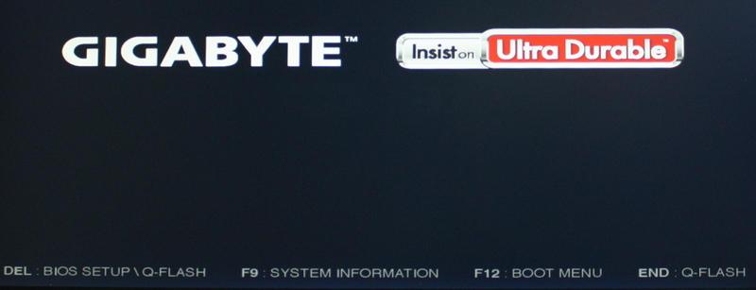
SMAS1 Splash Screen (Press F12 for Boot Menu)

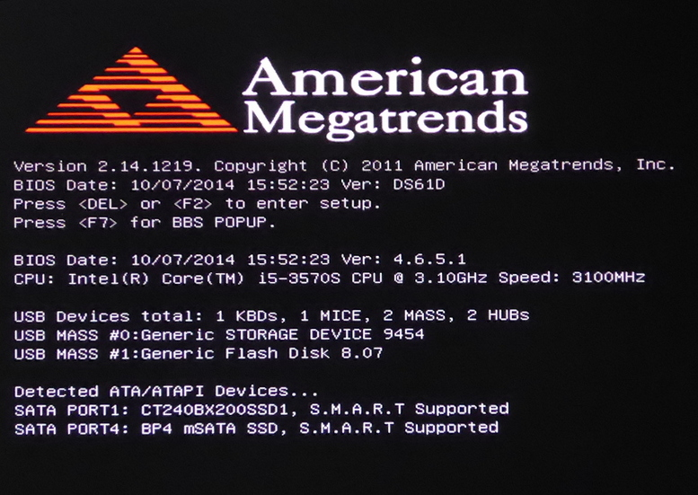
AllSky Splash Screen (Press F7 for Boot Menu)

STANDALONE RESTORE
With the computer off insert the backup external usb hard drive into an usb3 (blue) port. Insert the Windows 10 usb stick into any other usb port.
Depending on the computer it may or may not boot the usb stick on power up. If it does not you have to enter the BIOS boot menu when you see the BIOS splash screen by press one of the Function keys. Note each motherboard bios boot menu has a difference function key, this will be shown on the power up splash screen. Sometimes this screen is not seen because the monitor is not yet ready; you have to be fast to catch it.
On SMAS1 (GigaByte motherboard) press F12 BOOT MENU then select “Flash”.
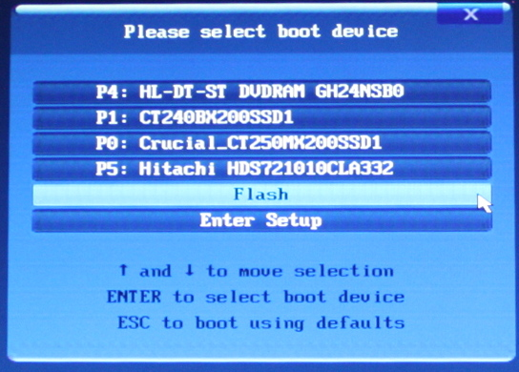

On AllSky (Shuttle motherboard) press F7 for BBS POPUP then select “Flash”.
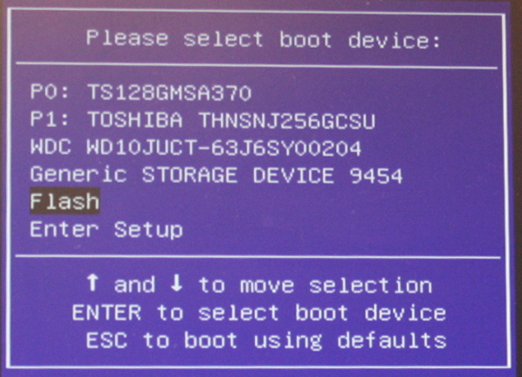
This will boot the Windows install usb flash thumb drive.

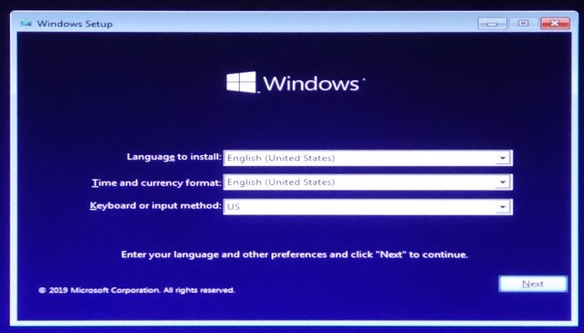
Select “Next”

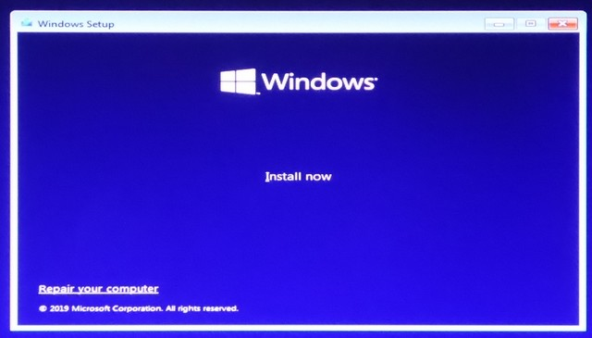
Select “Repair your computer”

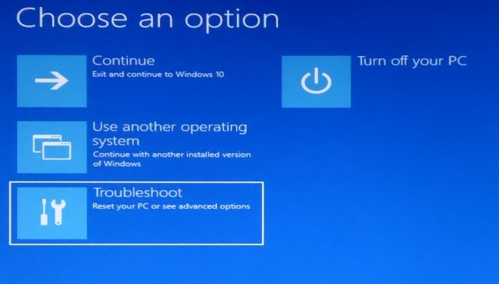
Select “Troubleshoot”

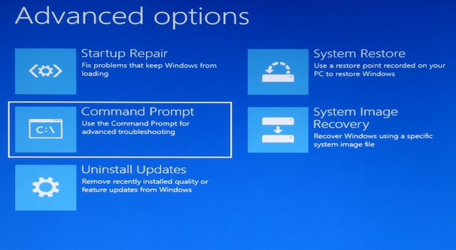
Select “Command Prompt”
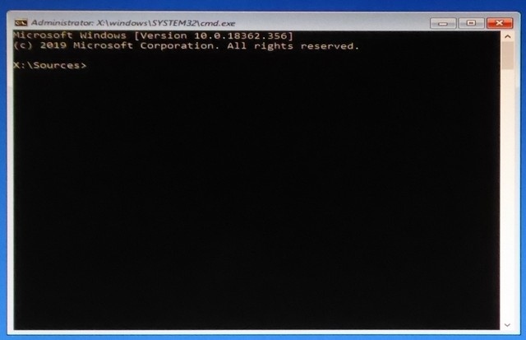
The Command Prompt Window will appear

Enter the commands as indicated in the COMMAND WINDOW section that follows.

COMMAND WINDOW for New or to Wipe the Disk
Use this procedure if installing a new disk drive or to wipe the existing one as if it were new.
Items in red bold is what you type. For a detailed example see COMMAND WINDOW Example at the end of this document.

>diskpart
DISKPART> list disk
Select the disk # you want to restore to, in this example we use 0.
DISKPART> select disk 0
DISKPART> clean
DISKPART> create partition primary
DISKPART> format fs=nts quick label="new"
DISKPART> active
DISKPART> list vol
Note the Volume with the Label of "new" and use its number, in this example we use 0.
Next you need to find the drive Ltr of where the backup files are located. This is the external usb drive that you have plugged in. It should have a Label of “SMAS Backup” or something like that.
DISKPART> select vol 0
Assign drive letter that is not listed under Ltr in the list, in this example we use C.
DISKPART> assign letter=c
DISKPART> list vol
Note the drive letter of your new disk and of the backup drive where the snapshot files are.
DISKPART> exit

In this example the system drive is "C" and the backup drive is "F"
>f:
Select the directory where snapshot64.exe is located on the backup drive.
F:\>cd backup
In this example it is in the “backup” folder, you can do a “dir” to find it.
F:\Backup>snapshot64
Run the backup/restore program this will bring up the snapshot window.

Proceed to the SNAPSHOT WINDOWS section that follows.

COMMAND WINDOW to Overwrite the Disk
This procedure is only needed if you could NOT boot windows and had to use the USB stick to boot.
You can run the backup/restore program from windows and overwrite the system by just running snapshot64 from windows and follow the SNAPSHOT WINDOWS procedure section.

Use this procedure to overwrite the existing disk, most of the time you can use this.
Items in red bold is what you type. For a detailed example see COMMAND WINDOW Example at the end of this document.

>diskpart
DISKPART> list vol
Note the Volume with the Ltr of “C” is the one you want to restore to.
Next you need to find the drive Ltr of where the backup files are located. This is the external usb drive that you have plugged in. It should have a Label of “SMAS Backup” or something like that.
DISKPART> exit

In this example the system drive is "C" and the backup drive is "F"
>f:
Select the directory where snapshot64.exe is located on the backup drive.
F:\>cd backup
In this example it is in the “backup” folder, you can do a “dir” to find it.
F:\Backup>snapshot64
Run the backup/restore program this will bring up the snapshot window.

Proceed to the SNAPSHOT WINDOWS section that follows.

SNAPSHOT WINDOWS
In this example the backup usb drive is “F” and the restore to drive is “C”

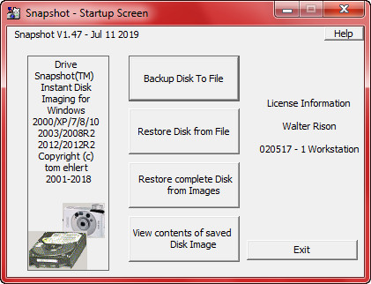
Select “Restore Disk from File”

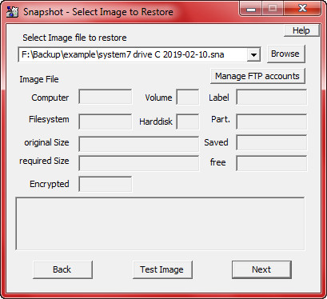
Select “Browse”

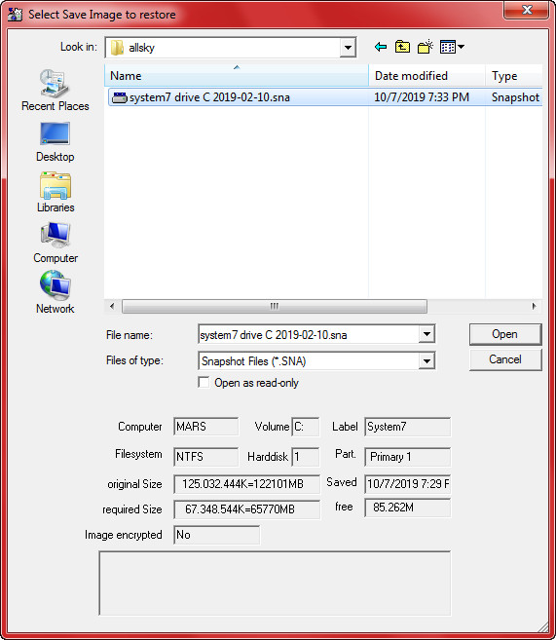
Navigate to the folder where the backup image is located and select “Open”

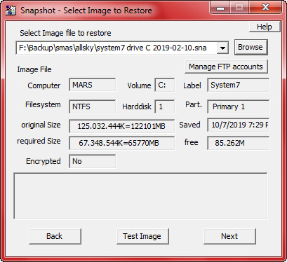
Select “Next”

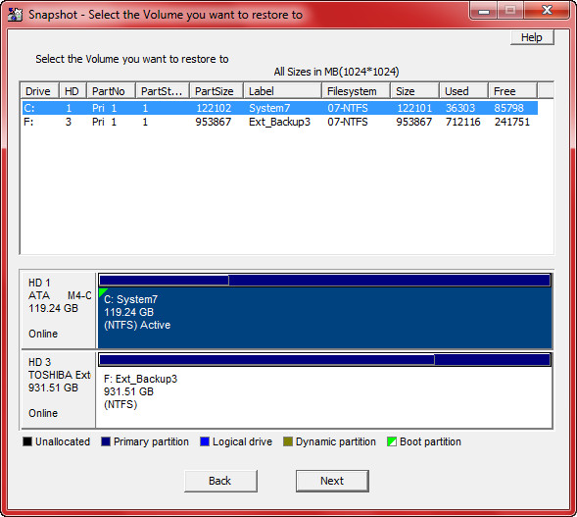
Click the Drive to restore to from the list, then select “Next”

The next window will only appear if you are restoring from a activate system. It will not appear if you booted from the Windows USB stick.
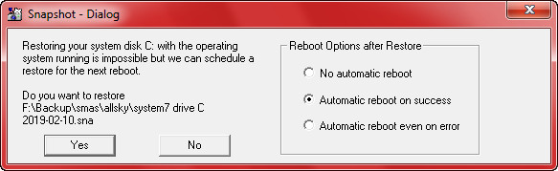
Select “Automatic reboot on success” then select “Yes” to start the restore.

WHAT IF THE SYSTEM WON’T BOOT!

There are two options if the restored drive won’t boot.

- Reboot with the Windows USB stick and get to the command prompt and enter the following command:
  - bootrec /rebuildbcd
  - Then remove the Windows USB stick and reboot.

- Reboot with the Windows USB stick and install windows on the drive you are restoring to. Do a new install wiping everything from the drive. Do not enter a registration key, just select “Skip”. After Windows installs insert the USB backup drive and run “snaphost64”. Then follow the SNAPSHOT WINDOWS to Restore Example from above.

If this does not work you may have to look in the BIOS and see if the boot order and drives are correct, sometimes Windows changes them.

COMMAND WINDOW Example
Items in red bold is what you type.

Microsoft Windows [Version 10.0.18362.365]
(C) 2019 Microsoft Corporation. All rights reserved.

X:\Sources>diskpart

Microsoft DiskPart version 10.0.19362.1

Copyright (C) Microsoft Corporation.
On computer: MININT-DSFVL9M

DISKPART> list disk

Disk ### Status Size Free Dyn Gpt
-------- ------------- ------- ------- --- ---
Disk 0 Online 119 GB 0 B
Disk 1 Online 238 GB 0 B
Disk 2 No Media 0 B 0 B
Disk 3 Online 931 GB 0 B
Disk 4 Online 7689 MB 0 B

Note most of the time disk 0 is the system boot drive you will restore to.

DISKPART>select disk 0

Disk 0 is now the selected disk.

DISKPART> clean

DiskPart succeeded in cleaning the disk.
Note this just deleted the partition so you have a blank disk.

DISKPART> create partition primary

DiskPart succeeded in creating the specified partition.

DISKPART> format fs=ntfs quick label=”new”

100 percent completed

DiskPart succeefuly formatted the volume.

DISKPART> active

DiskPart marked the current partition as active.

DISKPART>
DISKPART> list vol

Volume ### Ltr Label Fs Type Size Status Info
---------- --- ----------- ----- ---------- ------- --------- --------
Volume 0 new NTFS Partition 119 GB Healthy
Volume 1 D Data1 NTFS Partition 238 GB Healthy
Volume 2 E Removable 0 B No Media
Volume 3 F SMAS Backup NTFS Partition 1862 GB Healthy
Volume 4 G W10INSTAL FAT32 Removable 7679 MB Healthy

Note select the volume with the label of “new”.
DISKPART>select vol 0

Volume 0 is the selected volume.

DISKPART> assign letter=C

DiskPart successfully assigned the drive letter or mount point.

DISKPART> exit

Leaving DiskPart...

Note make a note of the “SMAS Backup” drive letter; this is used in the following steps. In this example it is “F”.

X:\Sources>F:
F:\>cd backup
F:\backup>snapshot64

This runs the snapshot program to restore the disk image. See the SNAPSHOT WINDOWS section to complete the restore.

